The flecks of gold in this pan are the only pure elements visible in this scene.

Chapter 3

Chemical Compounds

ook around you. Do you think you see anything composed of just one element…  any objects consisting only of carbon, or of gold, or of hydrogen? The correct answer is almost certainly no. If you are lucky enough to have a diamond ring,



you have a piece of carbon that is almost pure (although a gemologist would tell you that diamonds contain slight impurities that give each stone its unique character). If you have a “gold” ring, you have a *mixture* of gold with other metals, added to give the ring greater strength.

Even though a few elements, such as carbon and gold, are sometimes found in elemental form in nature, most of the substances we see around us consist of two or more elements that have combined chemically to form more complex substances called compounds. For example, in nature, the element hydrogen is combined with other elements, such as oxygen and carbon, in compounds such as the water and

sugar used to make a soft drink. (Perhaps you are sipping one while you read.) In this chapter, you will learn to (1) define the terms *mixture* and *compound* more precisely, (2) distinguish betweenelements, compounds, and mixtures, (3) describe how elements combine to form compounds, (4) construct systematic names for some chemical compounds, and (5) describe the characteristics of certain kinds of chemical compounds. The chapter will also expand your ability to visualize the basic structures of matter.

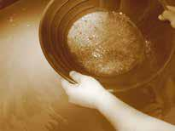

3.1 Classification of Matter



3.2 Compounds and Chemical Bonds

3.3 Molecular Compounds

3.4 Naming Binary

Covalent

Compounds

3.5 Ionic Compounds

Review Skills

The presentation of information in this chapter assumes that you can already perform the tasks listed below. You can test your readiness to proceed by answering the Review Questions at the end of the chapter. This might also be a good time to read the Chapter Objectives, which precede the Review Questions.

Describe the particle nature of solids, liquids, and gases. (Section 2.1) Convert between the names and symbols for the common elements. (Table 2.1)

Given a periodic table, write the number of the group to which each element belongs. (Figure 2.3)

Given a periodic table, identify the alkali metals, alkaline earth metals, halogens, and noble gases. (Section 2.3)

Using a periodic table, classify elements as metals, nonmetals, or metalloids. (Section 2.3)

Describe the nuclear model of the atom.

(Section 2.4)

Define the terms ion, cation, and anion.

(Section 2.4)

Define the terms covalent bond, molecule, and diatomic. (Section 2.5) Describe the covalent bond in a hydrogen molecule, H2. (Section 2.5)

69

70 Chapter 3  Chemical Compounds



3.1 Classification of Matter

Objective 2

**Figure 3.1**

Before getting started on your chemistry homework, you go into the kitchen to make some pasta for your six‑year‑old nephew. You run water into a pan, adding a few shakes of salt, and while you’re waiting for it to boil, you pour a cup of coffee. When the water begins to boil, you pour in the pasta. Then you add some sugar to your coffee.

Pure water, the sucrose in white sugar, and the sodium chloride in table salt are all examples of chemical compounds. A **compound** is a substance that contains two or more elements, with the atoms of those elements always combining in the same whole‑number ratio (Figure 3.1). There are relatively few chemical elements, but there are millions of chemical compounds. Compounds in our food fuel our bodies, and the compounds in gasoline fuel our cars. They can alter our moods and cure our diseases.

Water is composed of molecules that contain two atoms of hydrogen and one atom of oxygen. We describe the composition of water with the chemical formula H2O. White sugar is a highly purified form of sucrose, whose chemical formula is C12H22O11. Its molecules are composed of 12 carbon atoms, 22 hydrogen atoms, and 11 oxygen atoms. Sodium and chlorine atoms combine in a one‑to‑one ratio to form sodium chloride, NaCl, which is the primary ingredient in table salt.

Elements Versus Compounds

**ELEMENTS**

Hydrogen is composed

of molecules with

two hydrogen atoms.

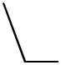H2 molecule

**COMPOUNDS**

Neon is composed Silver exists as an

of independent atoms. assembly of silver atoms.

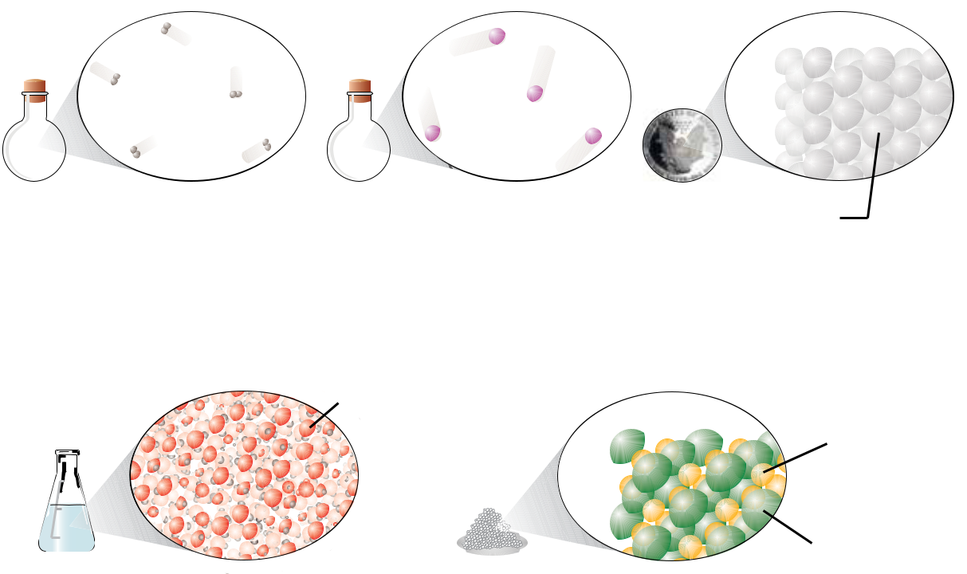

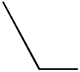 Neon atom Silver atom

Water is composed of molecules that contain one oxygen atom and two hydrogen atoms.

500

 400

300

 200

Water

molecule, H2O

Sodium chloride exists as an assembly of sodium and chloride ions, always in a one-to-one ratio.

Sodium ion

100

Chloride ion

|  |  |  |  |
| --- | --- | --- | --- |
| 3.1 Classification of Matter | | 71 |  |
| Note that a **chemical formula** is a concise written description of the components |  |  |  |
| Objective 2 |  |  |
| of a chemical compound. It identifies the elements in the compound by their symbols |  |  |  |
| and describes the relative number of atoms of each element with subscripts. If an |  |  |  |
| element symbol in a formula is not accompanied by a subscript, the relative number of |  |  |  |
| atoms of that element is assumed to be one. |  |  |  |
| Pure water, sodium chloride, and sucrose always have the composition described in |  |  |  |
| their chemical formulas. In other words, their composition is constant. Elements, too, |  |  |  |
| have a constant composition described by a chemical formula. (We have seen that the |  |  |  |
| formula for hydrogen is H2.) When a substance has a constant composition—when it |  |  |  |
| Objective 3 |  |  |
| can be described by a chemical formula—it must by definition be either an element or |  |  |  |
| a compound, and it is considered a **pure substance**. For example, the symbol Na refers |  |  |  |
| Objective 4 |  |  |
| to pure sodium. The formula Na2CO3 refers to pure sodium carbonate and tells us that |  |  |  |
| this compound is always composed of sodium, carbon, and oxygen in a constant atom |  |  |  |
| ratio of 2:1:3. |  |  |  |
| **Mixtures** are samples of matter that contain two or more pure substances and have |  |  |  |
| Objective 3 |  |  |

variable composition (Figure 3.2). For example, when salt, NaCl, and water, H2O, are combined, we know the resulting combination is a mixture because we can vary the percentage of these two pure substances. You can add one, two, or ten teaspoons of salt to a pan of water, and the result will still be salt water.

|  |  |  |  |
| --- | --- | --- | --- |
|  | **Figure 3.2** | |  |
|  | Automobile Exhaust—a Mixture | |  |
|  | The components and amounts vary. | |  |
|  |  |  |  |
|  |  | Objective 3 |  |
| Unburned |  |  |  |
| gasoline | Nitrogen oxides, | |  |
| Water, H2O | NO and NO2 | |  |
|  |  |  |

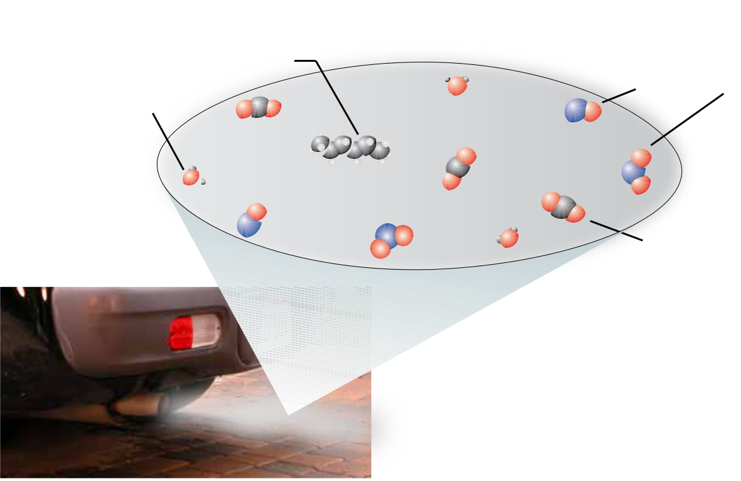

Carbon dioxide,

CO2

72 Chapter 3 

Sample Study Sheet 3.1

Classification of Matter

Objective 3

Objective 4

Chemical Compounds

The following sample study sheet and Figure 3.3 show the questions you can ask to discover whether a sample of matter is an element, a compound, or a mixture.



**Tip-off** You are asked to classify a sample of matter as a pure substance or amixture; or you are asked to classify a pure substance as an element or a compound.

**General Steps** The following general procedure is summarized in Figure 3.3.

To classify a sample of matter as a pure substance or a mixture, ask one or both of the following questions:

*Does it have a constant composition?* If it does, it is a pure substance. Ifit has variable composition, it is a mixture.

*Can the sample as a whole be described with a chemical formula?* If itcan, it is a pure substance. If it cannot, it is a mixture.

To classify a pure substance as an element or a compound, ask the following question:

*Can it be described with a single symbol?* If it can, it is an element. If itschemical formula contains two or more different element symbols, it is a compound.

**Example** See Example 3.1.

**Figure 3.3**

Classification of Matter

Objective 3

Objective 4

Matter

Does it have a constant composition?

Can it be described with a chemical formula?

|  |  |  |  |
| --- | --- | --- | --- |
| Yes |  |  | No |
|  |  |  |  |



Pure Substance Mixture

Can it be described with a single symbol?



|  |  |  |  |
| --- | --- | --- | --- |
| Yes |  |  | No |
|  |  |  |  |



|  |  |  |  |
| --- | --- | --- | --- |
| Element | Compound | coﬀee with |  |
|  |  |  |
|  |  | cream and sugar |  |
| hydrogen, H2 |  |  |  |
|  | water, H2O |  |  |



|  |  |  |  |  |  |
| --- | --- | --- | --- | --- | --- |
|  | 3.2 Compounds and Chemical Bonds | | | 73 |  |
|  |  |  |  |  |  |
| Example 3.1 - Classification of Matter |  |  |  |  |  |
| Many of us have a bottle in our medicine cabinet containing a mild disinfectant | | |  |  |  |
| Objective 3 |  |  |
| consisting of hydrogen peroxide and water. The liquid is about 3% | hydrogen peroxide, | |  |  |  |
| Objective 4 |  |  |
| H2O2, and about 97% water. Classify each of the following as a pure substance or a | | |  |  |  |
| mixture. If it is a pure substance, is it an element or a compound? |  |  |  |  |  |



1. the liquid disinfectant
2. the hydrogen peroxide, H2O2, used to make the disinfectant
3. the hydrogen used to make hydrogen peroxide

*Solution*

1. We know that the liquid disinfectant is a mixture for two reasons. It is composed of two pure substances (H2O2 and H2O), and it has variable composition.
2. Because hydrogen peroxide can be described with a formula, H2O2, it must be a pure substance. Because the formula contains symbols for two elements, it represents a compound.
3. Hydrogen can be described with a single symbol, H or H2, so it is a pure substance and an element.



Exercise 3.1 - Classification of Matter

The label on a container of double‑acting baking powder tells us that it contains cornstarch, bicarbonate of soda (also called sodium hydrogen carbonate, NaHCO3), sodium aluminum sulfate, and acid phosphate of calcium (which chemists call calcium dihydrogen phosphate, Ca(H2PO4)2). Classify each of the following as a pure substance or a mixture. If it is a pure substance, is it an element or a compound?

1. calcium
2. calcium dihydrogen phosphate
3. double-acting baking powder



Objective 3

Objective 4

3.2 Compounds and Chemical Bonds

The percentage of H2O2 in the mixture of hydrogen peroxide and water that is used as a disinfectant can vary, but the percentage of hydrogen in the compound water is always the same. Why? One of the key reasons that the components of a given compound are always the same, and present in the same proportions, is that the atoms in a compound are joined together by special kinds of attractions called **chemical** **bonds**. Because of the nature of these attractions, the atoms combine in specific ratiosthat give compounds their constant composition. This section will introduce you to the different types of chemical bonds and provide you with the skills necessary to predict the types of chemical bonds between atoms of different elements.

74 Chapter 3  Chemical Compounds

**Equal and Unequal Sharing of Electrons**

H2



Objective 5

Objective 7

Let’s first consider the compound hydrogen chloride, HCl. When HCl is dissolved in water, the resulting mixture is called hydrochloric acid. Not only is this mixture a very common laboratory agent, but it is also used in food processing and to treat the water in swimming pools.

In Section 2.5, we learned about the bond between hydrogen atoms in H2 molecules. We saw that the two electrons in the H2 molecule are shared equally between the atoms and can be viewed as an electron‑charge cloud surrounding the hydrogen nuclei. This sharing creates a covalent bond that holds the atoms together. There is also a covalent bond between the hydrogen atom and the chlorine atom in each molecule of HCl. It is very similar to the covalent bond in hydrogen molecules, with one important exception.

The difference between the H–Cl bond and the H–H bond is that the hydrogen and chlorine atoms in HCl do not share the electrons in the bond equally. In the hydrogen‑chlorine bond, the two electrons are attracted more strongly to the chlorine atom than to the hydrogen atom. The negatively charged electrons in the bond shift toward the chlorine atom, giving it a partial negative charge, δ−, and giving the hydrogen atom a partial positive charge, δ+ (Figure 3.4). The lower case Greek delta, δ, is a symbol that represents *partial* or *fractional*.

When the electrons of a covalent bond are shared unequally, the bond is called a **polar covalent bond**. Due to the unequal sharing of the electrons in the bond, a polarcovalent bond has one atom with a partial positive charge, δ+, and one atom with a partial negative charge, δ−.

|  |  |  |  |  |
| --- | --- | --- | --- | --- |
| **Figure 3.4** | |  |  |  |
| Hydrogen Chloride Molecule | | Electrons shift toward the chlorine atom, | |  |
|  |  |  |
|  |  | forming partial plus and minus charges. | |  |
| Objective 5 |  |
|  |  | δ+ | δ− |  |

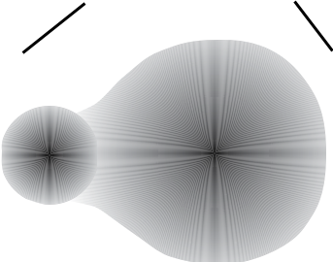

Hydrogen attracts electrons less. H Cl

Chlorine attracts electrons more.

If the electron‑attracting ability of one atom in a bond is much greater than the others, there is a large shift in the electron cloud, and the partial charges are large. If the electron‑attracting ability of one atom in a covalent bond is only slightly greater than the others, there is not much of a shift in the electron cloud, and the partial charges

Objective 7 are small. When the difference in electron‑attracting abilities is negligible (or zero), the atoms in the bond will have no significant partial charges. We call this type of bond a **nonpolar covalent bond**. The covalent bond between hydrogen atoms in H2 is an example of a nonpolar covalent bond.

|  |  |
| --- | --- |
| 3.2 Compounds and Chemical Bonds | 75 |

**Transfer of Electrons**

Sometimes one atom in a bond attracts electrons so much more strongly than the other that one or more electrons are fully transferred from one atom to another. This commonly happens when metallic atoms combine with nonmetallic atoms. A nonmetallic atom usually attracts electrons so much more strongly than a metallic atom that one or more electrons shift from the metallic atom to the nonmetallic atom. For example, when the element sodium combines with the element chlorine to form sodium chloride, NaCl, the chlorine atoms attract electrons so much more strongly than the sodium atoms that one electron is transferred from each sodium atom to a chlorine atom.

When an electron is transferred completely from one uncharged atom to another, the atom that loses the electron is left with one more proton than electron and acquires a +1 charge overall. It therefore becomes a cation (Section 3.4). For example, when an uncharged sodium atom with 11 protons and 11 electrons loses an electron, it is left with 11 protons (a charge of +11) and 10 electrons (a charge of -10), yielding an overall +1 charge.

|  |  |  |
| --- | --- | --- |
| Na | → | Na+ + e− |
| 11p/11e− |  | 11p/10e− |
| +11 + (-11) = 0 |  | +11 + (-10) = +1 |

In contrast, an uncharged atom that gains an electron will have one more electron than proton, so it forms an anion with a -1 charge. When a chlorine atom gains an electron from a sodium atom, the chlorine atom changes from an uncharged atom with 17 protons and 17 electrons to an anion with 17 protons and 18 electrons and an overall -1 charge.

Objective 6

Objective 6

Objective 6



|  |  |  |
| --- | --- | --- |
| Cl + e− | → | Cl− |
| 17p/17e− |  | 17p/18e− |
| +17 + (-17) = 0 |  | +17 + (-18) = −1 |

Atoms can transfer one, two, or three electrons. Thus cations can have a +1, +2, or +3 charge, and anions can have a -1, -2, or -3 charge.

Because particles with opposite charges attract each other, there is an attraction between cations and anions. This attraction is called an **ionic** **bond**. For example, when an electron is transferred from a sodium atomto a chlorine atom, the attraction between the +1 sodium cation and the -1 chlorine anion is an ionic bond (Figure 4.5).

You will see as you read more of this book that substances that have ionic bonds are very different from those that have all covalent bonds. For example, compounds that have ionic bonds, such as the sodium chloride in table salt, are solids at room temperature and pressure, but compounds with all covalent bonds, such as hydrogen chloride and water, can be gases and liquids as well as solids.

**The Salt-Encrusted Shore of The Dead Sea**

Salt (sodium chloride) is an ionic compound. Water is molecular.

76 Chapter 3  Chemical Compounds

|  |  |  |  |  |  |  |  |  |  |  |  |  |  |  |  |  |
| --- | --- | --- | --- | --- | --- | --- | --- | --- | --- | --- | --- | --- | --- | --- | --- | --- |
|  |  |  |  |  |  |  |  |  |  |  | e− | |  |  |  |  |
|  |  |  |  |  |  |  |  |  | Sodium atom, Na | | | |  | Chlorine atom, Cl | |  |
|  |  |  |  |  |  |  |  |  | metallic element | |  |  |  |  |
|  |  |  |  |  |  |  |  |  |  |  |  | nonmetallic element | |  |
|  |  |  |  |  |  |  |  |  |  |  |  |  |
|  |  |  |  |  |  |  |  |  |  |  |  |  |  |  |
|  |  |  |  | Chlorine gas, Cl2 | | | | |  |  |  |  |  |  |  |  |
|  |  |  |  | Each Na atom | |  |  |  | Each Cl atom | |  |
|  |  |  |  |  |  |  |  |  |  |  |  |  |
|  |  |  |  |  |  |  |  |  |  |  |  |
|  |  |  |  |  |  |  |  |  | loses one electron | | | |  | gains one electron | |  |
|  |  |  | Sodium metal, Na | | | | | | and gets smaller | |  |  |  | and gets larger | |  |
|  |  |  |  |  |  |  |  |  |  |  |
|  |  |  |  |  |  |  |  |  | Sodium ion, Na+ | | + |  | − | Chlorine ion, Cl− | |  |
|  |  |  |  |  |  |  |  |  |  |  |
|  |  |  |  |  |  |  |  |  |  |
|  |  |  |  |  |  |  |  |  | metallic cation | |  |  |  | nonmetallic anion | |  |
|  |  |  |  |  |  |  |  |  |  |  |  |  |
|  |  |  |  |  |  |  |  |  |  |  | |  | |  |  |  |
|  |  |  |  |  |  |  |  |  |  | Ionic bond, an attraction | | | | | |  |
|  |  |  |  |  |  |  |  |  |
| **Figure 3.5** | |  |  |  |  |  |  |  |  | between a cation and an anion | | | | | |  |
|  |  | Objective 6 | | | |  |  |  |  |  |  |  |  |  |
| Ionic Bond Formation | | | |  |  |  |  |  |  |  |  |  |  |  |  |  |

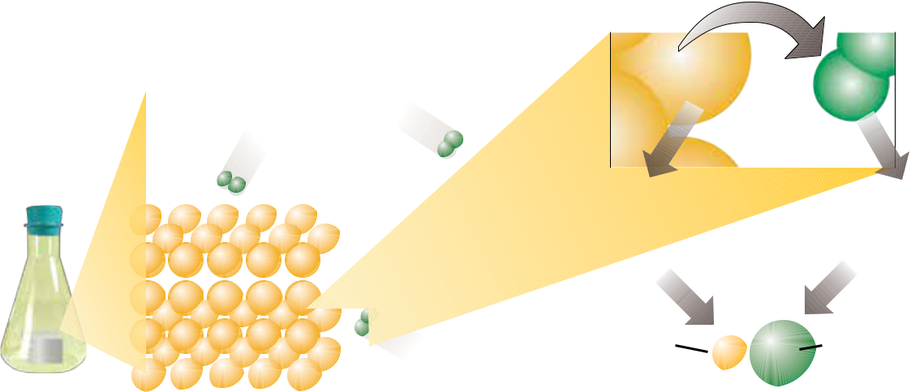

Objective 7

**Summary of Covalent and Ionic Bond Formation**

When atoms of different elements form chemical bonds, the electrons in the bonds can shift from one bonding atom to another.

The atom that attracts electrons more strongly will acquire a negative charge, and the other atom will acquire a positive charge.

The more the atoms differ in their electron‑attracting ability, the more the electron cloud shifts from one atom toward another.

If there is a large enough difference in electron‑attracting ability, one, two, or three electrons can be viewed as shifting completely from one atom to another. The atoms become positive and negative ions, and the attraction between them is called an ionic bond.

If the electron transfer is significant but not enough to form ions, the atoms acquire partial positive and partial negative charges. The bond in this situation is called a polar covalent bond.

If there is no shift of electrons or if the shift is negligible, no significant charges will form, and the bond will be a nonpolar covalent bond.

It might help, when thinking about these different kinds of bonds, to compare them to a game of tug‑of‑war between two people. The people are like the atoms with a chemical bond between them, and the rope is like the electrons in the bond. If the two people tugging have the same (or about the same) strength, the rope will not move (or not move much). This leads to a situation that is like the nonpolar covalent bond. If one person is stronger than the other person, the rope will shift toward that person, the way the electrons in a polar covalent bond shift toward the atom that attracts them more. If one person can pull a lot harder than the other person can, the stronger person pulls the rope right out of the hands of the weaker one. This is similar to the formation of ions and ionic bonds, when a nonmetallic atom pulls one or more electrons away from a metallic atom.

|  |  |
| --- | --- |
| 3.2 Compounds and Chemical Bonds | 77 |

Figure 3.6 summarizes the general differences between nonpolar covalent bonds, polar covalent bonds, and ionic bonds.

**Nonpolar Covalent Bond**

Equal sharing of electrons



Both atoms attract No signi cant

electrons equally charges form.

(or nearly so).

**Figure 3.6**

Covalent and Ionic Bonds

Objective 7

**Polar Covalent Bond**

Unequal sharing of electrons

is atom attracts

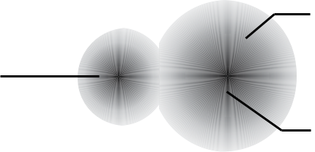

electrons more strongly.

Partial positive charge δ+ δ−

Partial negative charge.

**Ionic Bond**

Strong attraction between positive and negative charges.

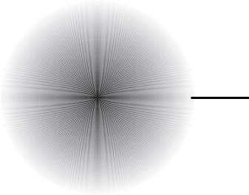

is atom loses

one or more electrons and gains a positive charge.

is atom attracts

electrons so much more

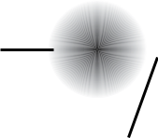

+ − strongly than the other

atom that it gains one or

more electrons and gains a

negative charge.

Ionic bond

**Predicting Bond Type**

The simplest way to predict whether a bond will be ionic or covalent is to apply the following rules.

When a nonmetallic atom bonds to another nonmetallic atom, the bond is covalent.

When a metallic atom bonds to a nonmetallic atom, the bond is *usually* ionic.

Some bonds between a metallic atom and a nonmetallic atom are better described as covalent. For now, however, we will keep our guidelines simple. All nonmetal‑nonmetal combinations lead to covalent bonds, and except when you are told otherwise, you can assume that all bonds between metallic atoms and nonmetallic atoms are ionic bonds.

Objective 8

78 Chapter 3  Chemical Compounds

**Classifying Compounds**

Objective 9

Compounds can be classified as molecular or ionic. **Molecular compounds** are composed of molecules, which are uncharged collections of atoms held together by all covalent bonds. **Ionic compounds** contain cations and anions held together by ionic bonds (Figure 3.7). You will see some exceptions later in this text, but for now, if a formula for a compound indicates that all the elements in it are nonmetals, you can assume that all of the bonds are covalent bonds, which form molecules, and that the compound is a molecular compound. We will assume that metal‑nonmetal combinations lead to ionic bonds and ionic compounds.

|  |  |  |  |  |  |  |  |
| --- | --- | --- | --- | --- | --- | --- | --- |
| **Figure 3.7** |  |  |  |  |  |  |  |
|  |  | Objective 9 | |  |  |  |
| Classifying Compounds | |  |  |  |  |
| **Molecular compound** | | | | **Ionic compound** |  |
|  |  |  |
|  | Hydrogen chloride, HCl, gas | | | | | Sodium chloride, NaCl, solid |  |
| HCl molecule |  |  |  |  |  | Nonmetallic |  |
|  |  |  |  |  |  | anions |  |
|  |  |  |  |  |  | Metallic |  |
|  |  | Nonmetal | | Nonmetal | | cations |  |
|  |  |  |  |

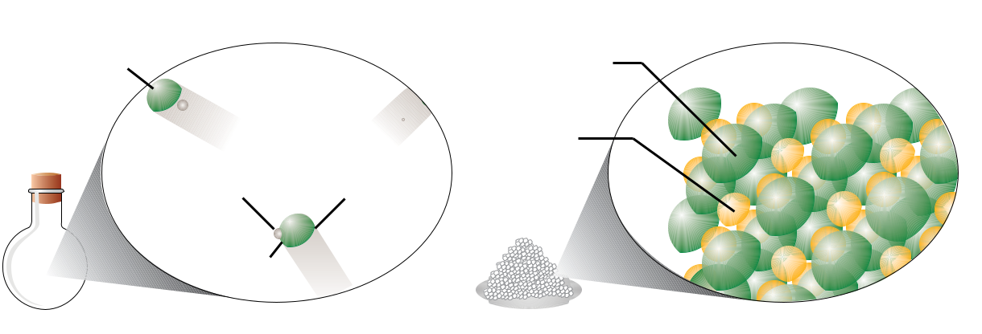

Covalent bond



Example 3.2 - Classifying Compounds

Objective 9 Classify each of the following as either a molecular compound or an ionic compound.

1. calcium chloride, CaCl2 (used for de-icing roads)
2. ethanethiol, C2H5SH (a foul-smelling substance used to odorize natural gas)

*Solution*

1. Calcium, Ca, is a metal, and chlorine, Cl, is a nonmetal. We expect the bonds between them to be ionic, so calcium chloride is an ionic compound.
2. Carbon, hydrogen, and sulfur are all nonmetallic elements, so we expect the bonds between them to be covalent bonds. The formula, C2H5SH, tells us that ethanethiol is composed of molecules that each contain two carbon atoms, six hydrogen atoms, and one sulfur atom. Ethanethiol is a molecular compound.



Exercise 3.2 - Classifying Compounds

Objective 9 Classify each of the following substances as either a molecular compound or an ionic compound.

1. formaldehyde, CH2O (used in embalming fluids)
2. magnesium chloride, MgCl2 (used in fireproofing wood and in paper manufacturing)

|  |  |
| --- | --- |
| 3.3 Molecular Compounds | 79 |



3.3 Molecular Compounds

Have you ever wondered why salt dissolves so quickly in water but oil does not?…why bubbles form when you open a soft drink can?… why a glass of water fizzes when an Alka-Seltzer tablet is plopped into it? What’s going on at the submicroscopic level that makes these things happen? To answer these questions, you need to know more about the structure of water, including the spatial arrangement of atoms in water molecules. The purpose of this section is to begin to describe the three-dimensional structure of molecular compounds such as water.

Earlier we saw that when some elements form ionic and covalent bonds, their atoms gain, lose, or share electrons. This suggests an important role for electrons in chemistry. However, chemists have also found that for most elements, some electrons are more influential in the formation of chemical bonds than others are. Of chlorine’s 17 electrons, for example, only seven are important in predicting how chlorine will bond. Of sulfur’s 16 electrons, only six are important; of phosphorus’s 15 electrons, only five are important. Chemists noticed that the important electrons, called **valence** **electrons**, are equal in number to the element’s “A-group” number. For example, thenonmetallic elements in group 7A (F, Cl, Br, and I) have seven valence electrons, those in group 6A (O, S, and Se) have six valence electrons, those in group 5A (N and P) have five, and carbon (C) in group 4A has four.

A more precise definition of valence electrons, and an explanation for why chlorine has seven, sulfur six, and so on, will have to wait until you learn more about atomic theory in Chapter 11. For now, it is enough to know the numbers of valence electrons for each nonmetallic atom and know how they are used to explain the bonding patterns of nonmetallic atoms.

The valence electrons for an element can be depicted visually in an **electron-dot** **symbol**. (Electron-dot symbols are known by other names, including electron-dotstructures, electron-dot diagrams, and Lewis electron-dot symbols.) An electron-dot symbol that shows chlorine’s seven valence electrons is



Cl

Electron-dot symbols are derived by placing valence electrons (represented by dots) to the right, left, top, and bottom of the element’s symbol. Starting on any of these four sides, we place one dot at a time until there are up to four unpaired electrons around the symbol. If there are more than four valence electrons for an atom, the remaining electrons are added one by one to the unpaired electrons to form up to four pairs.



X X X XX XXX



There is no set convention for the placement of the paired and unpaired electrons around the symbol. For example, the electron-dot symbol for chlorine atoms could be



Cl or Cl or Cl or Cl



Objective 10

Objective 11

Objective 11

80 Chapter 3  Chemical Compounds

Objective 11

There seems to be something special about having eight valence electrons (often called an *octet* of electrons). For example, the noble gases (group 8A) have an octet of electrons (except for helium, which has only two electrons total), and they are so stable that they rarely form chemical bonds with other atoms.



Ne Ar Kr Xe 



When atoms other than the noble gas atoms form bonds, they often have eight electrons around them in total. For example, the unpaired electron of a chlorine atom often pairs with an unpaired electron of another atom to form one covalent bond. This gives the chlorine atom an octet of eight electrons around it: two from the two‑electron covalent bond and six from its three lone pairs. This helps us explain why chlorine gas is composed of Cl2 molecules.



ClClCl Cl



Objective 12

Objective 12

Objective 11

Note that each chlorine atom in Cl2 has an octet of electrons. Apparently, the formation of an octet of electrons leads to stability.

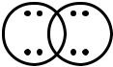

Cl  Cl

This way of depicting a molecule—using the elements’ symbols to represent atoms and using dots to represent valence electrons—is called a **Lewis structure**. Covalent bonds are usually represented by lines in Lewis structures, so the Lewis structure of a Cl2 molecule can have either of two forms:



Cl Cl or Cl Cl



The nonbonding pairs of electrons are called **lone pairs**. Each atom of chlorine in a Cl2 molecule has 1 covalent bond and 3 lone pairs.



|  |  |  |  |  |  |  |  |
| --- | --- | --- | --- | --- | --- | --- | --- |
| Lone pairs |  |  |  |  |  | Lone pairs |  |
| (nonbonding electrons) |  | Cl |  | Cl |  | (nonbonding electrons) |  |
|  |  |  |  |



covalent bond

Some atoms do not form octets of electrons when they bond. For example, hydrogen atoms form one bond, achieving a total of two electrons around them. The reason is similar to the reason that chlorine atoms form one covalent bond and have three lone pairs. Atoms of helium, which is one of the very stable noble gases, have two electrons. When hydrogen atoms form one covalent bond, they get two electrons around them, like helium atoms. Knowing that hydrogen atoms form one covalent bond and that chlorine atoms form one bond and have three lone pairs helps us to build the Lewis

|  |  |
| --- | --- |
| 3.3 Molecular Compounds | 81 |

structure for a hydrogen chloride molecule, HCl:



H + Cl HCl or H Cl



Like chlorine, the other elements in group 7A also have seven valence electrons, so their electron-dot symbols are similar to that of chlorine. The unpaired dot can be placed on any of the four sides of each symbol.



FBr I 



Objective 11

In order to obtain octets of electrons, these atoms tend to form compounds in which they have one bond and three lone pairs. Note how the Lewis structures of hydrogen fluoride, HF (used in the refining of uranium), hydrogen bromide, HBr (a pharmaceutical intermediate), and hydrogen iodide, HI (used to make iodine salts) resemble the structure of hydrogen chloride.



|  |  |  |  |  |  |  |  |  |  |
| --- | --- | --- | --- | --- | --- | --- | --- | --- | --- |
| H |  | F | H |  | Br | H |  | I |  |
|  |  |  |  |
| Hydrogen fluoride | | | Hydrogen bromide | | | Hydrogen iodide | | |  |



The nonmetallic elements in group 6A (oxygen, sulfur, and selenium) have atoms with six valence electrons:



OS  Se 



Objective 11

(The unpaired dots can be placed on any two of the four sides of each symbol.) These elements usually gain an octet by forming two covalent bonds and two lone pairs, as in

|  |  |  |  |  |  |  |  |  |  |  |
| --- | --- | --- | --- | --- | --- | --- | --- | --- | --- | --- |
| water, H2O, and hydrogen sulfide, | | | | | | | H2S. | | |  |
| H |  | O |  | H | H |  | S |  | H |  |
|  |  |  |  |  |
|  | Water | | | | Hydrogen sulfide | | | | |  |



Nitrogen and phosphorus, which are in group 5A, have atoms with five valence electrons:



N P 



Objective 11

They form three covalent bonds to pair their three unpaired electrons and achieve an octet of electrons around each atom. Ammonia, NH3, and phosphorus trichloride, PCl3, molecules are examples.



|  |  |  |  |  |  |  |  |  |  |  |  |  |
| --- | --- | --- | --- | --- | --- | --- | --- | --- | --- | --- | --- | --- |
| H |  | N | |  | H | Cl |  | P | |  | Cl |  |
|  |  |  |  |  |
|  |  |  |  |  |  |  |  |  |  |  |  |  |
|  |  | H | |  |  |  |  | Cl | | | |  |
| Ammonia | | | | | | Phosphorus trichloride | | | | | |  |



PCl3 is used to make pesticides and gasoline additives.

82 Chapter 3 

Objective 11

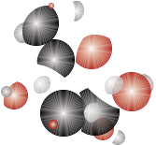

Chemical Compounds

Carbon, in group 4A, has four unpaired electrons in its electron-dot symbol.



C



Predictably, carbon atoms are capable of forming four covalent bonds (with no lone pairs). Examples include methane, CH4, the primary component of natural gas, and ethane, C2H6, and propane, C3H8, which are also found in natural gas, but in smaller quantities.

|  |  |  |  |  |  |  |  |  |  |  |  |  |  |  |  |  |  |  |  |  |  |  |  |  |  |  |  |  |  |  |
| --- | --- | --- | --- | --- | --- | --- | --- | --- | --- | --- | --- | --- | --- | --- | --- | --- | --- | --- | --- | --- | --- | --- | --- | --- | --- | --- | --- | --- | --- | --- |
|  |  |  | H | | | |  |  | H | |  | H | | | |  |  | H | |  |  | H | | | | H | | | |  |
|  |  |  |  |  |  |  |  |  |  |  |  |  |  |  |  |  |  |  |  |  |  |  |  |  |  |  |  |  |  |  |
|  | H |  | C | |  | H | H |  | C | |  | C | |  | H | H |  | C | |  |  | C | |  |  | C | |  | H |  |
|  |  |  |  |  |  |  |  |  |  |  |
|  |  |  |  |  | | |  |  |  |  |  |  |  |  |  |  |  |  |  |  |  |  |  |  |  |  |  |  |  |  |
| [Web](http://preparatorychemistry.com/Bishop_Jmol_Alkanes.htm) |  |  | H | | | |  |  | H | |  | H | | | |  |  | H | |  |  | H | | | | H | | | |  |
| Methane | | | | | |  |  | Ethane | | | | | | |  |  |  |  | Propane | | | | | |  |  |  |  |  |
| [Molecules](http://preparatorychemistry.com/Bishop_Jmol_Alkanes.htm) |  |  |  |  |  |  |  |  |  |  |  |
|  |  |  |  |  |  |  |  |  |  |  |  |  |  |  |  |  |  |  |  |  |  |  |  |  |  |  |  |  |  |

Methane, ethane, and propane are **hydrocarbons**, compounds that contain only carbon and hydrogen. Fossil fuels that we burn to heat our homes, cook our food, and power our cars, are primarily hydrocarbons. For example, natural gas is a mixture of hydrocarbons with from one to four carbons, and gasoline contains hydrocarbon molecules with from six to twelve carbons. Like the hydrocarbons described above, many of the important compounds in nature contain a backbone of carbon‑carbon bonds. These compounds are called organic compounds, and the study of carbon-based compounds is called **organic chemistry**.

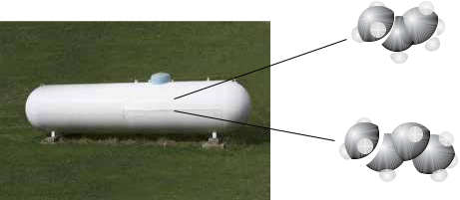

Propane, C3H8

Butane, C4H10

**Figure 3.8**

**Household Hydrocarbon**

Liquid petroleum gas is a mixture of the hydrocarbons propane and butane.

Table 3.1 shows electron-dot symbols for the nonmetallic atoms and lists their most common bonding patterns. Note that the sum of the numbers of bonds and lone pairs is always four for the elements in this table.

|  |  |  |  |  |  |  |  |  |  |  |  |  |  |  |  |  |  |  |  |  |  |  |  |  |  |  |  |  |  |  |  |  |  |  |  |  |  |  |  |  |  |  |
| --- | --- | --- | --- | --- | --- | --- | --- | --- | --- | --- | --- | --- | --- | --- | --- | --- | --- | --- | --- | --- | --- | --- | --- | --- | --- | --- | --- | --- | --- | --- | --- | --- | --- | --- | --- | --- | --- | --- | --- | --- | --- | --- |
|  |  |  |  |  |  |  |  |  |  |  |  |  |  |  |  |  |  |  |  |  |  |  |  |  |  |  |  | 3.3 | | | | | | | | | | Molecular Compounds | | | 83 |  |
| **Table 3.1** | | | | | |  |  |  |  |  |  |  |  |  |  |  |  |  |  |  |  |  |  |  |  |  |  |  |  |  |  |  |  |  |  |  |  |  |  |  |  |  |
| Electron-Dot Symbols and Usual Numbers of Bonds and Lone Pairs for Nonmetallic Elements | | | | | | | | | | | | | | | | | | | | | | | | | | | | | | | | | | | | | |  |  | Objective 13 |  |  |
|  |  |  |  |  |  |  |  |  |  |  |  |  |  |  |  |  |  |  |  |  |  |  |  |  |  |  |  |  |  |  |  |  |  |  |  |  |  |  |  |  |  |  |
| Group 4A | | | | | | Group 5A | | | | | | | | | | Group 6A | | | | | | | | | | | | Group 7A | | | | | | | | | |  |  |  |  |  |
| 4 valence electrons | | | | | | 5 valence electrons | | | | | | | | | | 6 valence electrons | | | | | | | | | | | | 7 valence electrons | | | | | | | | | | |  |  |  |  |
|  |  | X | | | |  |  |  |  | X | | | | | |  |  |  |  | X | | | | | | | |  |  |  |  |  | X | | | | |  |  |  |  |  |
|  |  |  |  |  |  |  |  |  |  |  |  |  |  |  |  |  |  |  |  |  |  |  |  |  |  |  |  |  |  |  |  |  |  |  |  |  |  | |  |  |  |  |
| 4 bonds | | | No lone | | | 3 bonds | | | | |  |  | 1 lone | | | 2 bonds | | | | |  |  |  | 2 lone | | | | 1 bond | | | | | | | | | 3 lone | |  |  |  |  |
|  |  |  |  | pairs | |  |  |  |  |  |  |  | pair | | |  |  |  |  |  |  |  |  | pairs | | | |  |  |  |  |  |  |  |  |  | pairs |  |  |  |  |  |
|  |  |  |  |  |  |  |  |  |  |  |  |  |  |  |  |  |  |  |  |  |  |  |  |  |  |  |  |  |  |  |  |  |  |  |  |  |  |  |  |  |  |  |
| carbon-C | | | | | | nitrogen-N | | | | | | | | | | oxygen-O | | | | | | | | | | | | fluorine-F | | | | | | | | | |  |  |  |  |  |
|  |  |  |  |  |  |  |  |  |  | N | |  |  |  |  |  |  |  |  | O | | |  |  |  |  |  |  |  |  |  |  |  |  |  |  | F |  |  |  |  |  |
|  |  | C | |  |  |  |  |  |  |  |  |  |  |  |  |  |  |  |  |
|  |  |  |  |  |  |  |  |  |  |  |  |  |  |  |  |  |  |  |  |  |  |  |  |  |  |  |  |  |  |  |  |  |
|  |  |  |  |  |  |  |  |  |  |  |  |  |  |  |  |  |  |  |  |  |  |  |  |  |  |  |  |  |  |  |  |  |  |  |  |  |  |  |  |  |
|  |  |  |  |  |  |  |  |  |  |  |  |  |  |  |  |  |  |  |  |  |  |  |  |  |  |  |  |  |  |  |  |  |  |  |  |  |  |  |  |  |  |  |
|  |  |  |  |  |  |  |  |  |  |  |  |  |  |  |  |  |  |  |  |  |  |  |  |  |  |  |  |  |  |  |  |  |  |  |  |  |  |  |  |  |  |  |
|  |  |  |  |  |  |  |  |  |  |  |  |  |  |  |  |  |  |  |  |  |  |  |  |  |  |  |  |  |  |  |  |  |  |  |  |  |  |  |  |  |  |  |
|  |  |  |  |  |  | phosphorus-P | | | | | | | | | | sulfur-S | | | | | | | | | | | | chlorine-Cl | | | | | | | | | |  |  |  |  |  |
|  |  |  |  |  |  |  |  |  |  | P | | |  | |  |  |  |  |  | S | |  | |  |  | |  |  |  |  |  |  |  |  | Cl | | |  |  |  |  |  |
|  |  |  |  |  |  |  |  |  |  |  | |  |  |  |  |  |  | |  |  | |  |  |  |  |  |  |  |  |  |  |  |
|  |  |  |  |  |  |  |  |  |  |  |  |  |  |  |  |  |  |  |  |  |  |  |  |  |  |  |  |  |  |  |  |  |  |  |  |  |  |  |  |  |  |  |
|  |  |  |  |  |  |  |  |  |  |  |  |  |  |  |  |  |  |  |  |  |  |  |  |  |  |  |  |  |  |  |  |  |  |  |  |  |  |  |  |  |  |  |
|  |  |  |  |  |  |  |  |  |  |  |  |  |  |  |  | selenium-Se | | | | | | | | | | | | bromine-Br | | | | | | | | | |  |  |  |  |  |
|  |  |  |  |  |  |  |  |  |  |  |  |  |  |  |  |  |  |  |  | Se | | | |  | | |  |  |  |  |  |  |  |  | Br | | |  |  |  |  |  |
|  |  |  |  |  |  |  |  |  |  |  |  |  |  |  |  |  |  |  |  |  |  |  |  |  |  |  |  |  |  |  |  |  |  |  |
|  |  |  |  |  |  |  |  |  |  |  |  |  |  |  |  |  |  |  |  |  |  |  |  |  |  |  |  |  |  |  |  |  |  |  |  |  | |  |  |  |  |  |
|  |  |  |  |  |  |  |  |  |  |  |  |  |  |  |  |  |  |  |  |  |  |  |  |  |  |  |  | iodine-I | | | | | | | | | |  |  |  |  |  |
|  |  |  |  |  |  |  |  |  |  |  |  |  |  |  |  |  |  |  |  |  |  |  |  |  |  |  |  |  |  |  |  |  |  |  |  |  | I |  |  |  |  |  |
|  |  |  |  |  |  |  |  |  |  |  |  |  |  |  |  |  |  |  |  |  |  |  |  |  |  |  |  |  |  |  |  |  |  |  |  |  |  |  |  |  |  |
|  |  |  |  |  |  |  |  |  |  |  |  |  |  |  |  |  |  |  |  |  |  |  |  |  |  |  |  |  |  |  |  |  |  |  |  |  |  |  |  |  |  |  |



Atoms can form **double bonds**, in which four electrons are shared between atoms. Double bonds are represented by double lines in a Lewis structure. For example, in a carbon dioxide molecule, CO2, each oxygen atom has two bonds to the central carbon atom.



O  C  O



Note that each atom in CO2 still has its most common bonding pattern. The carbon atom has four bonds and no lone pairs, and the oxygen atoms have two bonds and two lone pairs.

**Triple bonds**, in which six electrons are shared between two atoms, are less commonthan double bonds, but they do exist in molecules like the diatomic nitrogen molecule, N2. This triple bond gives each nitrogen atom its most common bonding pattern of three bonds and one lone pair.

N N

This text describes two ways to construct Lewis structures from chemical formulas. In this chapter, you will find that Lewis structures for many common substances can be drawn by giving each type of atom its most common number of covalent bonds and lone pairs. You will learn a more widely applicable procedure for drawing Lewis structures in Chapter 12.

To illustrate how Lewis structures can be drawn using the information on Table 3.1, let’s figure out the Lewis structure of methanol, CH3OH, which is often called methyl alcohol or wood alcohol. Methanol is a poisonous liquid that is used as a solvent.

84 Chapter 3  Chemical Compounds

Objective 14

Objective 15

Objective 15



[Web](http://preparatorychemistry.com/Bishop_Jmol_Alcohols.htm)

[Molecules](http://preparatorychemistry.com/Bishop_Jmol_Alcohols.htm)

Objective 14

Objective 15

When drawing its Lewis structure, we assume that the carbon atom will have four bonds (represented by four lines), the oxygen atom will have two bonds and two lone pairs, and each hydrogen atom will have one bond. The Lewis structure below meets these criteria.

H



H C O H



H

Methanol, CH3OH

(methyl alcohol)

Methanol is an alcohol, which is a category of organic compounds, not just the intoxicating compound in certain drinks. **Alcohols** are organic compounds that possess one or more –OH groups attached to a hydrocarbon group (a group that contains only carbon and hydrogen). Ethanol, C2H5OH, is the alcohol in alcoholic beverages (see Special Topic 3.1: *Intoxicating Liquids and the Brain*), while the alcohol in rubbing alcohol is usually 2‑propanol (Figure 3.9). These alcohols are also called methyl alcohol, CH3OH, ethyl alcohol, C2H5OH, and isopropyl alcohol, C3H7OH.



|  |  |  |  |  |  |  |  |  |  |  |  |  |  |  |  |  |  |  |  |  |  |  |  |
| --- | --- | --- | --- | --- | --- | --- | --- | --- | --- | --- | --- | --- | --- | --- | --- | --- | --- | --- | --- | --- | --- | --- | --- |
|  |  | H | |  | H | | | | | |  |  | H | |  | O | |  | H | | | |  |
|  |  |  |  |  |  |  |
|  |  |  |  |  |  |  |  |  | H | | | |  |
|  |  |  |  |  |  |  |  |  |  |  |  |  |  |  |  |  |  |
|  |  |  |  |  |  |  |  |  |  |  |  |  |  |  |  |  |  |  |  |  |  |  |  |
| H |  | C | |  | C | |  | O |  | H |  |  |  |  |  |  |  |  |  |  |  |  |  |
|  |  |  |  | H |  | C | |  | C | |  | C | |  | H |  |
|  |  |  |  |  |
|  |  |  |  |  |  |  |  |  |
|  |  |  |  |  |  |  |  |  |  |
|  |  |  |  |  |  |  |  |  |  |  |  |  |  |  |  |  |  |  |  |  |  |  |  |
|  |  | H | |  | H | | | | | |  |  | H | |  | H | |  | H | | | |  |
| Ethanol, C2H5OH | | | | | | | | | | | 2-propanol, C3H7OH | | | | | | | | | | | |  |
|  | (ethyl alcohol) | | | | | | | | | |  | (isopropyl alcohol) | | | | | | | | | | |  |



Check to see that each of these compounds follows our guidelines for drawing Lewis structures.

**Figure 3.9**

Products Containing Alcohols

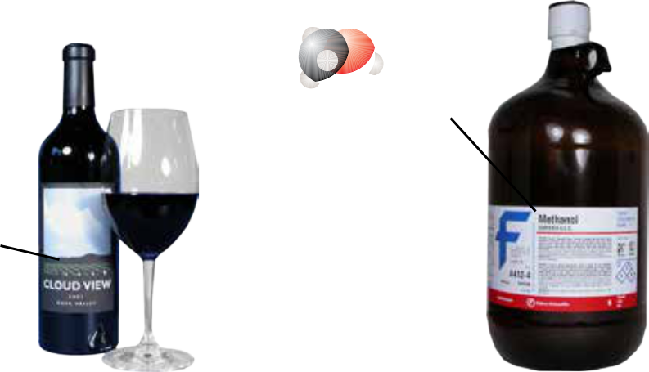

Methanol, CH3OH

A poison



Ethanol, C2H5OH

An intoxicant

|  |  |  |  |  |  |
| --- | --- | --- | --- | --- | --- |
| 3.3 | Molecular Compounds | | | 85 |  |
|  |  |  |  |  |  |
| Example 3.3 - Drawing Lewis Structures from Formulas |  |  |  |  |  |
| Draw a Lewis structure for each of the following formulas: |  |  |  |  |  |
|  |  | Objective 16 |  |  |
| a. phosphine, PH3 (used to make semiconductors) |  |  |  |  |  |
| b. hypochlorous acid, HOCl (used to bleach textiles) |  |  |  |  |  |
| c. CFC-11, CCl3F (used as a refrigerant) |  |  |  |  |  |
| d. C2H2, acetylene (burned in oxyacetylene torches) |  |  |  |  |  |



*Solution*

1. Phosphorus atoms usually have three covalent bonds and one lone pair, and hydrogen atoms have one covalent bond and no lone pairs. The following Lewis structure for PH3 gives each of these atoms its most common bonding pattern.



H P H



H

1. Hydrogen atoms have one covalent bond and no lone pairs, oxygen atoms usually have two covalent bonds and two lone pairs, and chlorine atoms usually have one covalent bond and three lone pairs.



* 1. O Cl

1. Carbon atoms usually have four covalent bonds and no lone pairs. Fluorine and chlorine atoms usually have one covalent bond and three lone pairs. The



fluorine atom can be put in any of the four positions around the carbon atom.



F



Cl C Cl



Cl



1. Carbon atoms form four bonds with no lone pairs, and hydrogen atoms form one bond with no lone pairs. To achieve these bonding patterns, there must be a triple bond between the carbon atoms.

H C  C H



|  |  |  |  |
| --- | --- | --- | --- |
| Exercise 3.3 - Drawing Lewis Structures from Formulas |  |  |  |
| Draw a Lewis structure for each of the following formulas: |  |  |  |
|  | Objective 16 |  |
| a. nitrogen triiodide, NI3 (explodes at the slightest touch) |  |  |  |
| b. hexachloroethane, C2Cl6 (used to make explosives) |  |  |  |
| c. hydrogen peroxide, H2O2 (a common antiseptic) |  |  |  |
| d. ethylene (or ethene), C2H4 (used to make polyethylene) |  |  |  |
|  |  |  |

86 Chapter 3  Chemical Compounds

**Molecular Shape**

Lewis structures are useful for showing how the atoms in a molecule are connected by covalent bonds, but they do not always give a clear description of how the atoms are arranged in space. For example, the Lewis structure for methane, CH4, shows the four covalent bonds connecting the central carbon atom to the hydrogen atoms:

H

H C H

H

Objective 17

Objective 18

However, this Lewis structure seems to indicate that the five atoms are all located in the same plane and that the angles between the atoms are all 90° or 180°. This is not true. The actual shape of a molecule can be more accurately predicted by recognizing that the negatively charged electrons that form covalent bonds and lone pairs repel each other. Therefore, the most stable arrangement of the electron‑groups is the molecular shape that keeps the groups as far away from each other as possible.

The best way to keep the negative charges for the four covalent bonds in a methane molecule as far apart as possible is to place them in a three‑dimensional molecular shape called **tetrahedral,** with angles of 109.5° between the bonds.

1. e shaded shape is a regular tetrahedron.

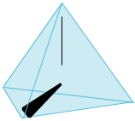

HC H

H

Objective 19 The angle formed by straight lines (representing bonds) connecting the nuclei of three adjacent atoms is called a **bond angle**.

Three ways to represent the methane molecule are shown in Figure 3.10. The first image, a *space‑filling model*, provides the most accurate representation of the electron‑charge clouds for the atoms in CH4. A *ball‑and‑stick model*, the second image, emphasizes the molecule’s correct molecular shape and shows the covalent bonds more clearly. The third image, a *geometric sketch*, shows a simple technique for describing three‑dimensional tetrahedral structures with a two‑dimensional drawing. Two hydrogen atoms are connected to the central carbon atom with solid lines. Picture these as being in the same plane as the carbon atom. A third hydrogen atom, connected to the central carbon with a solid wedge, comes out of the plane toward you. The fourth hydrogen atom, connected to the carbon atom by a dashed wedge, is situated back behind the plane of the page.

|  |  |  |  |  |  |  |
| --- | --- | --- | --- | --- | --- | --- |
|  |  |  |  | 3.3 Molecular Compounds | 87 |  |
| Extends |  |  |  |  |  |  |
| away from | | H | | bond angle |  |  |
| viewer |  |  |  |
|  |  |  | 109.5° |  |  |
| Extends |  |  |  |  |  |
| H | C | | H |  |  |
| toward |  |  |  |  |
| viewer | H |  |  |  |  |  |

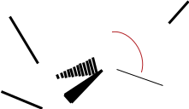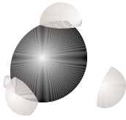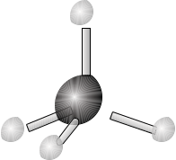

|  |  |  |  |  |  |  |
| --- | --- | --- | --- | --- | --- | --- |
| Space-filling model | Ball-and-stick model | | Geometric Sketch | |  |  |
|  |  |  |  |  | **Figure 3.10** |  |
|  |  |  |  |  | Three Ways to Describe |  |
|  | Objective 19 |  | Objective 20 |  |
|  |  |  |  |  | a Methane Molecule |  |

The nitrogen atom in an ammonia molecule, NH3, forms three covalent bonds and in addition has a lone pair of electrons. A lone pair on a central atom must be considered in predicting a molecule’s shape.



H N H



H

Like the carbon atom in a methane molecule, the nitrogen atom has four electron‑groups around it, so the ammonia molecule has a shape that is very similar to the shape of a CH4 molecule. However, the lone pair on the nitrogen atom repels neighboring electron‑groups more strongly than the bond pairs do, so the lone pair in the ammonia molecule pushes the bond pairs closer together than the bond pairs for methane. The bond angle is about 107° instead of 109.5°. Figure 3.11 shows three ways to represent the ammonia molecule.



HNH



H 107°

Space- lling model Ball-and-stick model Geometric sketch

**Liquid Water**

Objective 20

**Figure 3.11**

Three Ways to Describe an Ammonia Molecule

A chemist’s-eye view of the structure of liquid water starts with the prediction of the molecular shape of each water molecule. The Lewis structure of water shows that the oxygen atom has four electron‑groups around it: two covalent bonds and two lone pairs.



H O H



We predict that the four groups would be distributed in a tetrahedral arrangement to keep their negative charges as far apart as possible. Because the lone pairs are more repulsive than the bond pairs, the angle between the bond pairs is less than 109.5°. In fact, it is about 105° (Figure 3.12).

|  |  |  |  |  |  |  |  |  |
| --- | --- | --- | --- | --- | --- | --- | --- | --- |
| 88 | Chapter 3 Chemical Compounds | |  |  |  |  |  |  |
|  | **Figure 3.12** | |  |  |  | H | |  |
|  | Three ways to Describe | |  |  |  |  |
|  |  |  |  |  |
|  | a Water Molecule | |  |  |  |  | 105° |  |
|  |  |  |  |  |  |  |  |
|  |  |  |  |  |  | O | |  |
|  | Objective 20 |  |  |  |  |  |
|  |  |  |  |  |  | H |  |
|  |  |  |  |  |  |  |  |
|  |  | Space-filling model | Ball-and-stick model | | | Geometric Sketch | |  |

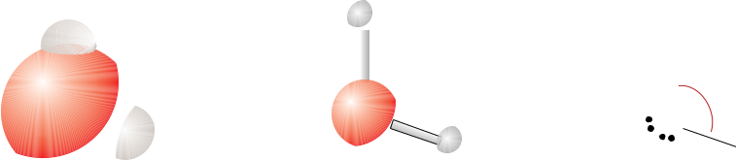

[Web](http://preparatorychemistry.com/Bishop_Jmol_tetrahedral.htm)

[Molecules](http://preparatorychemistry.com/Bishop_Jmol_tetrahedral.htm)

Objective 21

Because oxygen atoms attract electrons much more strongly than do hydrogen atoms, the O‑H covalent bond is very polar, leading to a relatively large partial minus charge on the oxygen atom (represented by a δ−) and a relatively large partial plus charge on the hydrogen atom (represented by a δ+).

* δ+

δ−O Hδ+

The attraction between the region of partial positive charge on one water molecule and the region of partial negative charge on another water molecule tends to hold water molecules close together (Figure 3.13). Remember that opposite charges attract each other and like charges repel each other.

**Figure 3.13**

Attractions Between Water Molecules

Objective 21

Attraction between partial positive

charge and partial negative charge



|  |  |  |  |  |  |  |
| --- | --- | --- | --- | --- | --- | --- |
|  | Hδ+ | |  | H δ+ | |  |
| δ+ |  |  |  |  |
|  |  |  |  |  |  |
| O | | δ+ |  |  |  |
| H |  | δ− | O δ− | |  |
|  |  | H |  |
|  |  | δ+ |  |  |  |  |
| δ+ |  |  | δ+ |  | δ+ |  |
|  |  | δ− |  |  |  |
|  |  |  |  | δ− |  |
|  |  |  |  |  |  |



Objective 22

As in other liquids, the attractions between water molecules are strong enough to keep them the same average distance apart, but they are weak enough to allow each molecule to be constantly breaking the attractions that momentarily connect it to some molecules and forming new attractions to other molecules (Figure 3.14). In other chapters, you will find this image of the structure of water useful in developing your understanding of what is happening when salt dissolves in your pasta water and when bubbles form in a soft drink or in a glass of Alka-Seltzer and water.

|  |  |
| --- | --- |
| 3.3 Molecular Compounds | 89 |

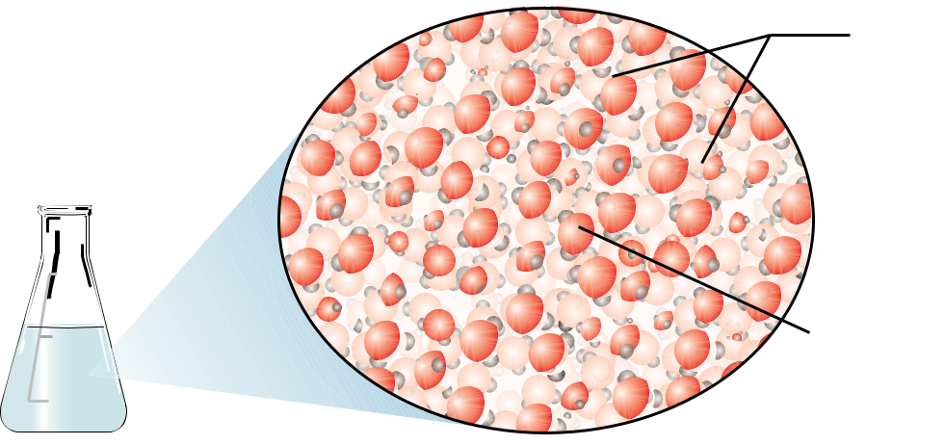

500

 400

300

 200

100

Attractions exist between

hydrogen and oxygen atoms

of diﬀerent water molecules.

Molecules break old attractions and

make new ones as they tumble

throughout the liquid.

|  |  |  |
| --- | --- | --- |
|  | **Figure 3.14** |  |
| Objective 22 |  |
| Liquid Water |  |
|  |  |

[**There is an animation at the textbook’s Web site that will help you to visualize**](https://preparatorychemistry.com/water_Canvas.html)[**the structure of water.**](https://preparatorychemistry.com/water_Canvas.html)



SPECIAL TOPIC 3.1 Molecular Shapes, Intoxicating Liquids, and the Brain

Even if we do not all have firsthand experience with alcoholic beverages, we all know that their consumption slows brain activity. Ethanol, or ethyl alcohol, is the chemical in alcoholic beverages that causes this change.

H H

H C C O H Ethanol, C2H5OH

H H

Information is transferred through our nervous system when one nerve cell causes the next nerve cell to fire. This firing is regulated by the attachment of molecules with *specific shapes* to large protein molecules that form part of the nerve cell’s membrane. When certain small molecules of the correct shape attach to the protein structures in the cell membranes, the cell is caused to fire. When certain other molecules attach, the firing of the cell is inhibited. For example, when a molecule called gamma‑aminobutanoic acid, or GABA, attaches to a protein molecule in certain nerve cells, it causes changes that inhibit the firing of the cell.

H H H O

H N C C C C O H GABA

H H H H

The GABA molecules are constantly attaching to the protein and then leaving again. When the GABA molecules are attached, the information transfer between nerve cells is inhibited. Anything that would make it easier for the GABA molecules to attach to the protein would lead to a slowing of the transfer of information between nerve cells.

Ethanol molecules can attach to the same protein as the GABA molecules, but they attach to a different site on the protein molecule. They change the shape of the protein in such a way that it becomes easier for the GABA molecules to find their position on the protein. Thus, when ethanol is present, the GABA molecules will become attached to the protein more often, inhibiting the firing of the cell. In this way, ethanol helps to slow the transfer of nerve information.

This slowing of the transfer of nerve information to the brain may not be a big problem to someone having a glass of wine with dinner at home, but when a person has a few drinks and drives a car, the consequences can be serious. If a deer runs in front of the car, we want the “put on the brake” signal sent from eyes to brain and then from brain to foot as quickly as possible.

90 Chapter 3  Chemical Compounds



3.4 Naming Binary Covalent Compounds

*Please excuse Lisa for being absent; she was sick and I had her shot.*



A note to the teacher to explain why a child was absent

We can probably assume that the parent who wrote this note meant the child was taken to the doctor for an injection, but who knows? Like everyone else, chemists need to be careful about how they use language, and the names and formulas for chemical compounds form the core of the language of chemistry. The purpose of this section is to describe the guidelines for constructing the names for **binary covalent compounds**, which are pure substances that consist of two nonmetallic elements. The water, H2O, you boil to cook your eggs and the methane, CH4, in natural gas that can be burned to heat the water are examples of binary covalent compounds.

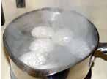

**Memorized Names**

Objective 23 Some binary covalent compounds, such as water, H2O, and ammonia, NH3, are known by common names that chemists have used for years. There is no systematic set of rules underlying these names, so each must simply be memorized. Organic compounds, such as methane, CH4, ethane, C2H6, and propane, C3H8, are named by a systematic procedure that you might learn later in your chemical education, but for now, it will be useful to memorize some of their names and formulas also (Table 3.2).

|  |  |  |  |  |  |  |
| --- | --- | --- | --- | --- | --- | --- |
|  | **Table 3.2** | |  |  |  |  |
| Objective 23 |  |  |  |  |
|  | Names and Formulas of some Binary Covalent Compounds | | | |  |  |
|  |  |  |  |  |  |  |
|  |  | Name | Formula | Name | Formula |  |
|  |  | water | H2O | ammonia | NH3 |  |
|  |  | methane | CH4 | ethane | C2H6 |  |
|  |  | propane | C3H8 |  |  |  |

**Systematic Names**

There are many different types of chemical compounds, and each type has its own set of systematic guidelines for writing names and chemical formulas. Thus, to write the name that corresponds to a formula for a compound, you need to develop the ability to recognize the formula as representing a specific type of compound. Likewise, to write a formula from a name, you need to recognize the type of compound the name represents. You also need to learn the guidelines for converting between names and formulas for that type of compound. You can recognize binary covalent compounds from their formulas, which contain symbols for only two nonmetallic elements. The general pattern of such formulas is AaBb, where “A” and “B” represent symbols for

|  |  |
| --- | --- |
| 3.4 Naming Binary Covalent Compounds | 91 |

nonmetals, and “a” and “b” represent subscripts (remember that if one of the subscripts is absent, it is understood to be 1). For example, because nitrogen and oxygen are nonmetallic elements, the formula N2O3 represents a binary covalent compound.

Nonmetallic elements



Binary covalent compound AaBb



Subscripts (may be absent)

Follow these steps to write the names for binary covalent compounds.

If the subscript for the first element is greater than one, indicate the identity of the subscript using prefixes from Table 3.3. We do not write mono- at the beginning of a compound’s name (see Example 3.4).

*Example:* We start the name for N2O3with *di-*.

**Table 3.3**

Prefixes Used in the Names of Binary Covalent Compounds

|  |  |  |  |
| --- | --- | --- | --- |
| Number of | Prefix | Number of | Prefix |
| atoms |  | atoms |  |
| 1 | mon(o) | 6 | hex(a) |
| 2 | di | 7 | hept(a) |
| 3 | tri | 8 | oct(a) |
| 4 | tetr(a) | 9 | non(a) |
| 5 | pent(a) | 10 | dec(a) |

Attach the selected prefix to the name of the first element in the formula. If no prefix is to be used, begin with the name of the first element.

*Example:* We indicate the N2portion of N2O3with *dinitrogen*.

Select a prefix to identify the subscript for the second element (even if its subscript is understood to be one). Leave the *a* off the end of the prefixes

that end in *a* and the *o* off of mono‑ if they are placed in front of an element whose name begins with a vowel (oxygen or iodine).

*Example:* The name of N2O3 grows to *dinitrogen tri-.*

Write the root of the name of the second element in the formula as shown in Table 3.4 on the next page.

*Example:* The name of N2O3 becomes *dinitrogen triox-.*

Add -ide to the end of the name.

*Example:* The name of N2O3 is *dinitrogen trioxide.*

Objective 24

Objective 28

Objective 25

|  |  |  |  |  |  |  |  |  |  |  |  |  |
| --- | --- | --- | --- | --- | --- | --- | --- | --- | --- | --- | --- | --- |
| 92 | Chapter 3 | Chemical Compounds | | | |  |  |  |  |  |  |  |
|  |  |  |  | **Table 3.4** |  |  |  |  |  |  |  |  |
|  | Objective 26 |  |  |  |  |  |  |  |  |  |  |
|  |  |  |  | Roots for Names of the Nonmetal Elements | | | |  |  |  |  |  |
|  |  |  |  |  |  |  |  |  |  |  |  |  |
|  |  |  |  | Element | Root | Element | Root | Element | Root | Element | Root |  |
|  |  |  |  | C | carb | N | nitr | O | ox | F | fluor |  |
|  |  |  |  |  |  | P | phosph | S | sulf | Cl | chlor |  |
|  |  |  |  |  |  |  |  |  |  |  |  |  |
|  |  |  |  |  |  |  |  | Se | selen | Br | brom |  |
|  |  |  |  |  |  |  |  |  |  | I | iod |  |
|  |  |  |  |  |  |  |  |  |  |  |  |  |



Objective 28

Objective 27

Objective 28

Example 3.4 - Naming Binary Covalent Compounds

Write the names that correspond to the formulas (a) N2O5, (b) NO2, and (c) NO. *Solution*

These formulas are in the form of AaBb, where A and B represent symbols for nonmetallic elements, so they are binary covalent compounds.

1. The first subscript in N2O5 is 2, so the first prefix is *di*. The first symbol, N, represents nitrogen, so the name for N2O5 begins with *dinitrogen*. The second subscript is 5, and the second symbol, O, represents oxygen. Therefore, the prefix *pent* combines with the root of oxygen, *ox* , and the usual ending, *ide*, to give *pentoxide* for the second part of the name. N2O5 is dinitrogen pentoxide**.** Notice that the *a* is left off *penta*, because the root *ox*begins with a vowel.
2. NO2 is nitrogen dioxide. We leave *mono* off the first part of the name.
3. NO is nitrogen monoxide. We leave *mono* off the first part of the name, but we start the second part of the name with *mon*. The *o* in *mono* is left off before the root *ox*.

Hydrogen atoms always form one covalent bond, and halogen atoms (group 17 or 7A) usually form one bond. Thus hydrogen reacts with halogens to form compounds with the general formula of HX, with the X representing the halogen. Because this is common knowledge among scientists and science students, these compounds are often named without prefixes. For example, HF can be named hydrogen fluoride or hydrogen monofluoride. Likewise, HCl can be named hydrogen chloride or hydrogen monochloride, HBr can be named hydrogen bromide or hydrogen monobromide, and HI can be named hydrogen iodide or hydrogen moniodide. For similar reasons, H2S can be named hydrogen sulfide or dihydrogen monosulfide.



Exercise 3.4 - Naming of Binary Covalent Compounds

Write names that correspond to the following formulas: (a) P2O5, (b) PCl3, (c) CO, (d) H2S, and (e) NH3.

|  |  |
| --- | --- |
| 3.4 Naming Binary Covalent Compounds | 93 |

**Converting Names of Binary Covalent Compounds to Formulas**

Now let’s go the other way and convert from systematic names to chemical formulas. The first step in writing formulas when given the systematic name of a binary covalent compound is to recognize the name as representing a binary covalent compound. It will have one of the following general forms.

prefix(name of nonmetal) prefix(root of name of nonmetal)ide (for example, dinitrogen pentoxide)

or (name of nonmetal) prefix(root of name of nonmetal)ide (for example, carbon dioxide)

or (name of nonmetal) (root of nonmetal)ide

(for example, hydrogen fluoride)

Follow these steps for writing formulas for binary covalent compounds when you are given a systematic name. Notice that they are the reverse of the steps for writing names from chemical formulas.

 Write the symbols for the elements in the order mentioned in the name.

 Write subscripts indicated by the prefixes. If the first part of the name has no prefix, assume it is mono-.

Remember that HF, HCl, HBr, HI, and H2S are often named without prefixes. You will also be expected to write formulas for the compounds whose nonsystematic names are listed in Table 3.2.



Objective 24

Objective 28

Example 3.5- Writing Formulas for Binary Covalent Compounds

|  |  |  |
| --- | --- | --- |
| Write the formulas that correspond to the following names: (a) dinitrogen tetroxide, |  |  |
| Objective 28 |  |

1. phosphorus tribromide, (c) hydrogen iodide, and (d) methane. *Solution*
   1. Because the name dinitrogen tetroxide has the following form, it must be binary covalent.

prefix(name of nonmetal) prefix(root of name of nonmetal)ide

The di‑ tells us there are two nitrogen atoms, and the tetr‑ tells us there are four oxygen atoms. Dinitrogen tetroxide is N2O4.

1. Because the name phosphorus tribromide has the following form, it must be binary covalent.

(name of nonmetal) prefix(root of name of nonmetal)ide

Because there is no prefix attached to phosphorus, we assume there is one phosphorus atom. Phosphorus tribromide is PBr3.

94 Chapter 3  Chemical Compounds

[**There is a tutorial**](https://preparatorychemistry.com/binary_covalent_nomenclature_Canvas.html)[**on the textbook’s**](https://preparatorychemistry.com/binary_covalent_nomenclature_Canvas.html)[**Web site that**](https://preparatorychemistry.com/binary_covalent_nomenclature_Canvas.html)[**provides practice**](https://preparatorychemistry.com/binary_covalent_nomenclature_Canvas.html)[**converting**](https://preparatorychemistry.com/binary_covalent_nomenclature_Canvas.html)[**between names**](https://preparatorychemistry.com/binary_covalent_nomenclature_Canvas.html)[**and formulas of**](https://preparatorychemistry.com/binary_covalent_nomenclature_Canvas.html)[**binary covalent**](https://preparatorychemistry.com/binary_covalent_nomenclature_Canvas.html)[**compounds.**](https://preparatorychemistry.com/binary_covalent_nomenclature_Canvas.html)

Objective 28

1. Because the name hydrogen iodide has the following form, it must be binary covalent.

(name of nonmetal) (root of name of nonmetal)ide

This is one of the binary covalent compounds that do not require prefixes. Iodine usually forms one bond, and hydrogen always forms one bond, so hydrogen iodide is HI.

1. Methane is on our list of binary covalent compounds with names you should memorize. Methane is CH4.



Exercise 3.5 - Writing Formulas for Binary Covalent Compounds

Write formulas that correspond to the following names: (a) disulfur decafluoride, (b) nitrogen trifluoride, (c) propane, and (d) hydrogen chloride.



3.5 Ionic Compounds

**Ionic compounds** are substances composed of ions attracted to each other by ionic

Ionic compounds play an important role in creating the excitement of a Fourth of July celebration.

bonds. Let’s consider how they play a part in a “typical” family’s Fourth of July. Before the family leaves the house to go to the holiday picnic, the kids are sent off

to brush their teeth and change into clean clothes. Their toothpaste contains sodium fluoride, a common cavity‑fighting ionic compound. The white shirts in their red, white, and blue outfits were bleached with the ionic compound sodium hypochlorite, the stains on their red pants were removed by potassium oxalate, and dyes were fixed to their blue hats by aluminum nitrate.

While the kids are getting ready, dad and mom get the picnic dinner together. The hot dogs they are packing are cured with the ionic compound sodium nitrite, and the buns contain calcium acetate as a mold inhibitor and calcium iodate as a dough conditioner. The soft drinks have potassium hydrogen carbonate to help trap the bubbles, the mineral water contains magnesium sulfate, and the glass for the bottles was made with a variety of ionic compounds. Because it will be dark before they get

home, Mom packs a flashlight as well. Its rechargeable batteries contain the ionic compounds cadmium hydroxide and nickel hydroxide.



When our family gets to the park, they find themselves a place on the lawn, which was fertilized with a mixture of ionic compounds, including iron(II) sulfate. They eat their dinner and play in the park until it’s time for the fireworks. The safety matches used to light the rockets contain barium chromate, and ionic compounds in the fireworks provide the colors: red from strontium chlorate, white from magnesium nitrate, and blue from copper(II) chloride.

Sodium fluoride is added to toothpaste to help fight tooth decay.

|  |  |
| --- | --- |
| 3.5 Ionic Compounds | 95 |

**Cations and Anions**

|  |  |  |  |  |  |  |  |
| --- | --- | --- | --- | --- | --- | --- | --- |
| Remember the sodium fluoride in the | | | kids’ toothpaste? It could be made from the | | |  |  |
| reaction of sodium metal with the nonmetallic atoms in fluorine gas. As you discovered | | | | | |  |  |
| in Section 3.2, metallic atoms hold some of their electrons relatively loosely, and as a | | | | | |  |  |
| Objective 29 |  |
| result, they tend to lose electrons and form cations. In contrast, | | | | | |  |  |
| nonmetallic atoms attract electrons more strongly than metallic | | | | | |  |  |
| atoms, and so nonmetals tend to gain electrons and form anions. | | | | | |  |  |
| Thus, when | a metallic | element and | a | nonmetallic | element |  |  |
| combine, the nonmetallic atoms often pull one or more electrons | | | | | |  |  |
| far enough away from the metallic atoms to form ions. The positive | | | | | |  |  |
| cations and the negative anions then attract each other to form | | | | | |  |  |
| ionic bonds. In the formation of sodium fluoride from sodium | | | | | |  |  |
| metal and fluorine gas, | | each sodium atom | | donates one | electron |  |  |
| to a fluorine | atom to form a Na+ cation and an F− anion. The | | | | |  |  |

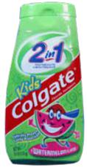

F− anions in toothpaste bind to the surface of your teeth, making them better able to resist tooth decay. This section provides you with more information about other cations and anions, including how to predict their charges and how to convert between their names and formulas.

**Predicting Ionic Charges**

It is useful to be able to predict the charges the atoms of each element are most likely to attain when they form ions. Because the periodic table can be used to predict ionic charges, it is a good idea to have one in front of you when you study this section.

We discovered in Chapter 2 that the atoms of the noble gases found in nature are uncombined with other atoms. The fact that the noble gas atoms do not gain, lose, or share their electrons suggests there must be something especially stable about having 2 (helium, He), 10 (neon, Ne), 18 (argon, Ar), 36 (krypton, Kr), 54 (xenon, Xe), or 86 (radon, Rn) electrons. This stability is reflected in the fact that nonmetallic atoms form anions in order to get the same number of electrons as the nearest noble gas.

All of the halogens (group 17) have one less electron than the nearest noble gas. When halogen atoms combine with metallic atoms, they tend to gain one electron each and form -1 ions (Figure 3.15). For example, uncharged chlorine atoms have 17 protons and 17 electrons. If a chlorine atom gains one electron, it will have 18 electrons like an uncharged argon atom. With a -18 charge from the electrons and a +17 charge from the protons, the resulting chlorine ion has a -1 charge. The symbol for this anion is Cl−. Notice that the negative charge is indicated with a “-” not “-1” or “ 1-”.

Cl + 1e− → Cl−

17p/17e− 17p/18e−

Objective 30

Objective 30

The nonmetallic atoms in group 16 (oxygen, O, sulfur, S, and selenium, Se) have two fewer electrons than the nearest noble gas. When atoms of these elements combine with metallic atoms, they tend to gain two electrons and form -2 ions (Figure 3.15).

96 Chapter 3  Chemical Compounds

For example, oxygen, in group 16, has atoms with eight protons and eight electrons. Each oxygen atom can gain two electrons to achieve ten, the same number as its nearest noble gas, neon. The symbol for this anion is O2−. Notice that the charge is indicated with “2-” not “-2”.

|  |  |  |  |  |  |  |
| --- | --- | --- | --- | --- | --- | --- |
|  | O | + | 2e− | → | O2− |  |
|  | 8p/8e− |  |  |  | 8p/10e− |  |
| Objective 30 |  |  |  |  |
|  | Nitrogen, N, and phosphorus, P, have three fewer electrons than the nearest noble gas. | | | | |  |
|  | When atoms of these elements combine with metallic atoms, they tend to gain three | | | | |  |
|  | electrons and form -3 ions (Figure 3.15). For example, nitrogen atoms have seven | | | | |  |
|  | protons and seven electrons. Each nitrogen atom can gain three electrons to achieve | | | | |  |
|  | ten, like neon, forming a N3− anion. | | | | |  |
|  | N | + | 3e− | → | N3− |  |
|  | 7p/7e− |  |  |  | 7p/10e− |  |

Hydrogen has one less electron than helium, so when it combines with metallic atoms, it forms a -1 ion, H− (Figure 4.15). Anions like H−, Cl−, O2−, and N3−, which contain single atoms with a negative charge, are called **monatomic anions**.

|  |  |  |
| --- | --- | --- |
| **Figure 3.15** |  |  |
| Objective 30 |  |
| The Making of an Anion |  |
|  |  |

When a

hydrogen

atom gains

one electron,

|  |  |  |  |
| --- | --- | --- | --- |
| 1 | +e– | H– |  |
| H |  |  |

or when an

atom in

group 15

gains three

electrons,

|  |  |  |  |  |
| --- | --- | --- | --- | --- |
| 15 |  |  |  |  |
| 7 | +3e | – |  |  |
| N | – |  |
| 15 |  | X3 |  |
|  |  |  |  |
| P |  |  |  |  |

or when an or when an

atom in atom

group 16 in group 17

gains two gains one

electrons, electron,

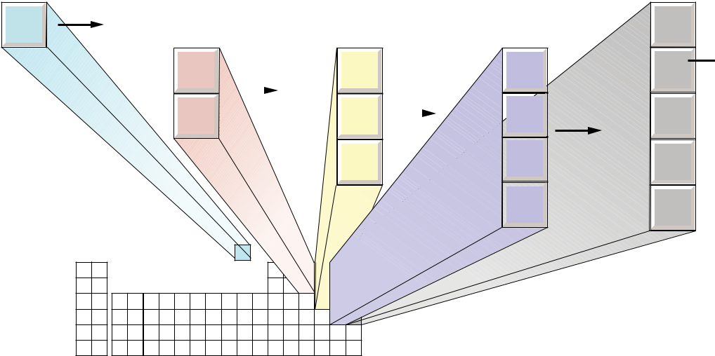

|  |  |  |  |  |  |  |  |
| --- | --- | --- | --- | --- | --- | --- | --- |
| 16 |  |  |  | 17 |  |  |  |
| 8 |  |  |  | 9 |  |  |  |
| O | +2e | – |  | F |  |  |  |
| 16 | – | 17 | +e– |  |  |
| S |  | X2 | Cl | X– |  |
|  |  |  | 35 |  |  |
| 34 |  |  |  |  |  |  |
| Se |  |  |  | Br |  |  |  |
|  |  |  |  | 53 |  |  |  |
|  |  |  |  | I |  |  |  |

it has the same number of electrons as an atom of the nearest noble gas.

|  |  |
| --- | --- |
| 18 |  |
| 2 |  |
| He |  |
| 10 | Atomic |
| Ne | number |
| 18 | equals |
| Ar | number of |
| 36 | electrons. |
| Kr |  |
| 54 |  |
| Xe |  |

Objective 30

Some metallic atoms lose enough electrons to create a cation that has the same number of electrons as the nearest smaller noble gas. For example, the alkali metals in group 1 all have one more electron than the nearest noble gas. When they react with nonmetallic atoms, they lose one electron and form +1 ions (Figure 3.16). For example, sodium has atoms with 11 protons and 11 electrons. If an atom of sodium loses one electron, it will have ten electrons like uncharged neon. With a -10 charge from the electrons and a +11 charge from the protons, the sodium ions have a +1

|  |  |  |  |  |  |
| --- | --- | --- | --- | --- | --- |
|  |  |  |  | 3.5 Ionic Compounds | 97 |
| overall charge. The symbol for this | | | | cation is Na+. Notice that the charge is indicated |  |
| with a “+” instead of “+1” or “1+”. | | | | |  |
| Na | → | Na+ | + | 1e− |  |
| 11p/11e− |  | 11p/10e− | |  |  |

The alkaline earth metals in group 2 all have two more electrons than the nearest noble gas. When they react with nonmetallic atoms, they tend to lose two electrons and form +2 ions (Figure 3.16). For example, calcium has atoms with 20 protons and 20 electrons. Each calcium atom can lose two electrons to achieve 18, the same number as its nearest noble gas, argon. The symbol for this cation is Ca2+. Note that the charge is indicated with “2+” not “+2”.

Ca → Ca2+ + 2e−

20p/20e− 20p/18e−

Aluminum atoms and the atoms of the group 3 metals have three more electrons than the nearest noble gas. When they react with nonmetallic atoms, they tend to lose three electrons and form +3 ions (Figure 3.16). For example, uncharged aluminum atoms have 13 protons and 13 electrons. Each aluminum atom can lose three electrons to achieve ten, like neon, forming an Al3+ cation.

Al → Al3+ + 3e−

13p/13e− 13p/10e−

Cations like Na+, Ca2+, and Al3+, which are single atoms with a positive charge, are called **monatomic cations**.

Objective 30

Objective 30

|  |  |  |  |
| --- | --- | --- | --- |
| When an | |  |  |
| atom in | |  |  |
| group 1 | |  |  |
| loses one | |  |  |
| electron, | |  |  |
| 1 |  |  |  |
| 3 |  |  |  |
| Li |  |  |  |
| 11 |  |  |  |
| Na |  |  |  |
| 19 | −e | − |  |
| K |  |
| 37 |  | X+ |  |
|  |  |  |
| Rb |  |  |  |
| 55 |  |  |  |
| Cs |  |  |  |
| 87 |  |  |  |
| Fr |  |  |  |

|  |  |  |  |  |  |  |  |  |
| --- | --- | --- | --- | --- | --- | --- | --- | --- |
| or when an | | |  |  |  |  |  |  |
| atom |  |  |  |  |  |  |  |  |
| in group 2 | |  |  |  |  |  |  |  |
| loses two | |  |  | or when an | | |  |  |
| electrons, | |  |  |  |  |
| 2 |  |  |  | atom |  |  |  |  |
|  |  |  | in group 3 | |  |  |  |
| 4 |  |  |  | loses three | |  |  |  |
| Be |  |  |  | electrons, | |  |  |  |
| 12 |  |  |  | 3 |  |  |  |  |
| Mg |  |  |  |  |  |  |  |
|  |  |  |  |  |  |  |  |
| 20 | −2e | − |  | 21 | −3e | − |  |  |
| Ca | X2+ | Sc | X3+ |  |
| 38 |  |  |  | 39 |  |  |  |  |
| Sr |  |  |  | Y |  |  |  |  |
| 56 |  |  |  |  |  |  |  |  |
| Ba |  |  |  |  |  |  |  |  |
| 89 |  |  |  |  |  |  |  |  |
| Ra |  |  |  |  |  |  |  |  |

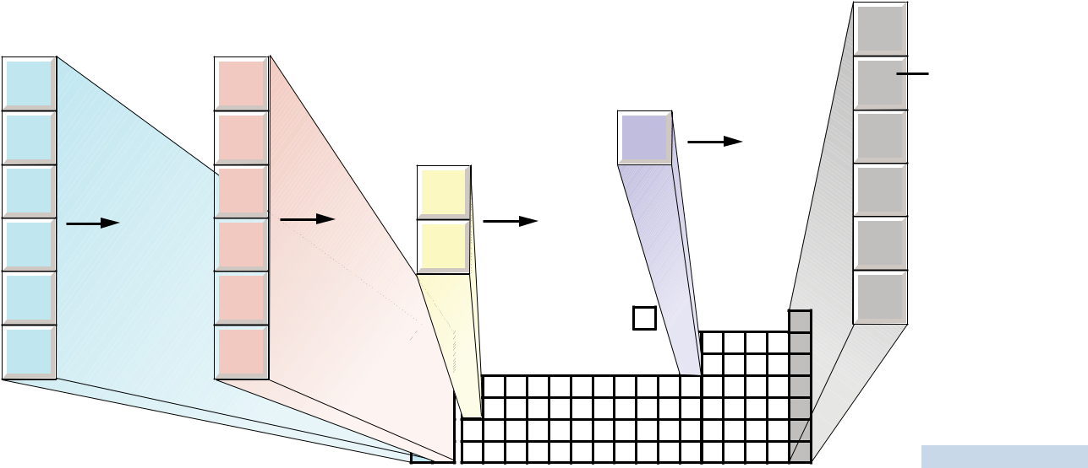

or when an

aluminum

atom

loses three

electrons,

|  |  |  |
| --- | --- | --- |
| 13 | −3e− |  |
| 13 |  |
| Al3+ |  |
| Al |  |

it has the same number of electrons as an atom of the nearest noble gas.

|  |  |  |
| --- | --- | --- |
| 18 |  |  |
| 2 |  |  |
| He | Atomic |  |
| 10 |  |
| Ne | number |  |
| 18 | equals |  |
| Ar | number of |  |
| 36 | electrons. |  |
| Kr |  |  |
| 54 |  |  |
| Xe |  |  |
| 86 |  |  |
| Rn |  |  |

Objective 30



**Figure 3.16**

The Making of a Cation

|  |  |  |  |  |
| --- | --- | --- | --- | --- |
| 98 | Chapter 3 | Chemical Compounds | |  |
|  |  |  | The metallic elements in groups other than 1, 2, or 3 also lose electrons to form |  |
|  |  |  | cations, but they do so in less easily predicted ways. It will be useful to memorize some |  |
|  |  |  | of the charges for these metals. Ask your instructor which ones you will be expected |  |
|  |  |  | to know. To answer the questions in this text, you will need to know that iron atoms |  |
|  | Objective 30 |  |  |
|  |  |  | form both Fe2+ and Fe3+, copper atoms form Cu+ and Cu2+, zinc atoms form Zn2+, |  |
|  |  |  | cadmium atoms form Cd2+, and silver atoms form Ag+. Figure 3.17 summarizes the |  |
|  |  |  | charges of the ions that you should know at this stage. |  |



|  |  |  |  |  |  |  |  |  |  |  |  |  |  |  |  |  |  |
| --- | --- | --- | --- | --- | --- | --- | --- | --- | --- | --- | --- | --- | --- | --- | --- | --- | --- |
| **Figure 3.17** | |  |  |  |  |  |  |  |  |  |  |  |  |  |  |  |  |
| Common Monatomic Ions | | |  |  |  |  |  |  |  |  |  |  |  |  |  |  |  |
|  | Objective 30 | |  |  |  |  |  |  |  |  |  |  |  |  |  | 18 |  |
|  |  |  |  |  |  |  |  |  |  |  |  |  |  |  |  | 8A |  |
| 1 | 2 |  |  |  |  |  |  |  |  | H– |  | 13 | 14 | 15 | 16 | 17 |  |
| 1A | 2A |  |  |  |  |  |  |  |  |  |  | 3A | 4A | 5A | 6A | 7A |  |
| Li+ Be2+ | |  |  |  |  |  |  |  |  |  |  |  |  | N3– O2– | | F– |  |
| Na+ | Mg2+ | 3 | 4 | 5 | 6 | 7 | 8 | 9 | 10 | 11 | 12 | Al3+ |  | P3– | S2– | Cl– |  |
| 3B | 4B | 5B | 6B | 7B | 8B | 8B | 8B | 1B | 2B |  |  |
|  |  |  |  |  |  |  |  |
| K+ | Ca2+ | Sc3+ |  |  |  |  | Fe2+ |  |  | Cu+ | Zn2+ |  |  |  | Se2– | Br– |  |
|  |  |  |  | Fe3+ |  |  | Cu2+ |  |  |  |  |
| Rb+ | Sr2+ | Y3+ |  |  |  |  |  |  |  | Ag+ | Cd2+ |  |  |  |  | I– |  |
| Cs+ | Ba2+ |  |  |  |  |  |  |  |  |  |  |  |  |  |  |  |  |
| Fr+ | Ra2+ |  |  |  |  |  |  |  |  |  |  |  |  |  |  |  |  |

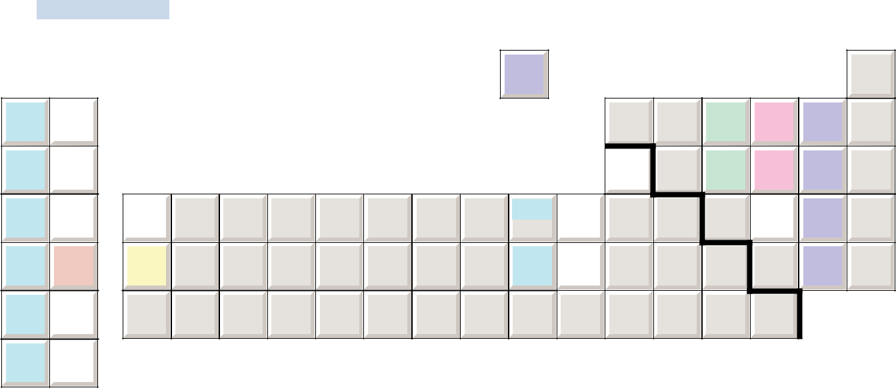

Objective 31

Objective 31

**Naming Monatomic Anions and Cations**

The monatomic anions are named by adding -ide to the root of the name of the nonmetal that forms the anion. For example, N3- is the nitride ion. The roots of the nonmetallic atoms are listed in Table 3.4, and the names of the anions are displayed in Table 3.5.

**Table 3.5**

Names of the Monatomic Anions

|  |  |  |  |  |  |
| --- | --- | --- | --- | --- | --- |
| Anion | Name | Anion | Name | Anion | Name |
| N3- | nitride | O2- | oxide | H- | hydride |
| P3- | phosphide | S2- | sulfide | F- | fluoride |
|  |  | Se2- | selenide | Cl- | chloride |
|  |  |  |  | Br- | bromide |
|  |  |  |  | I- | iodide |

|  |  |  |  |  |
| --- | --- | --- | --- | --- |
| 3.5 | Ionic Compounds | | 99 |  |
| The names of monatomic cations always start with the name of the metal, sometimes |  |  |  |  |
| followed by a Roman numeral to indicate the charge of the ion. For example, Cu+ |  |  |  |  |
| is copper(I), and Cu2+ is copper(II). The Roman numeral in each name represents |  |  |  |  |
| the charge on the ion and allows us to distinguish between more than one possible |  |  |  |  |
| charge. Notice that there is no space between the end of the name of the metal and the |  |  |  |  |
| parentheses with the Roman numeral. |  |  |  |  |
| If the atoms of an element always have the same charge, the Roman numeral is |  |  |  |  |
| unnecessary (and considered to be incorrect). For example, all cations formed from |  |  |  |  |
| sodium atoms have a +1 charge, so Na+ is named sodium ion, without the Roman |  |  |  |  |
| numeral for the charge. The following elements have only one possible charge, so it |  |  |  |  |
|  | Objective 31 |  |  |

would be incorrect to put a Roman numeral after their name.

The alkali metals in group 1 are always +1 when they form cations.

The alkaline earth metals in group 2 are always +2 when they form cations.

Aluminum and the elements in group 3 are always +3 when they form cations.

Zinc and cadmium always form +2 cations.

Although silver can form both +1 and +2 cations, the +2 is so rare that we usually name Ag+ as *silver ion*, not *silver(I) ion.* Ag2+ is named silver(II) ion.

We will assume that all of the metallic elements other than those mentioned above can have more than one charge, so their cation names will include a Roman numeral. For example, Mn2+ is named manganese(II). We know to put the Roman numeral in the name because manganese is not on our list of metals with only one charge.



Example 3.6 - Naming Monatomic Ions

Write names that correspond to the following formulas for monatomic ions: (a) Ba2+, (b) S2-, and (c) Cr3+.

*Solution*

1. Because barium is in group 2, the only possible charge is +2. When there is only one possible charge, metallic ions are named with the name of the metal. Therefore, Ba2+ is barium ion**.**
2. Monatomic anions are named with the root of the nonmetal and ‑ide, so S2- is sulfide ion**.**
3. Because chromium is not on our list of metals with only one possible charge, we need to indicate the charge with a Roman numeral. Therefore, Cr3+ is chromium(III) ion.



Exercise 3.6 - Naming Monatomic Ions

Write names that correspond to the following formulas for monatomic ions: (a) Mg2+, (b) F-, and (c) Sn2+.

Objective 31

Objective 31

|  |  |  |  |  |  |  |  |
| --- | --- | --- | --- | --- | --- | --- | --- |
| 100 | Chapter 3 | | Chemical Compounds | | | |  |
|  |  |  |  |  | |  |  |
|  |  |  |  | Example 3.7 - Formulas for Monatomic Ions | |  |  |
|  |  |  |  | Write | formulas that correspond to the following names for monatomic ions: | |  |
|  | Objective 31 | |  |  |
|  |  |  |  | (a) phosphide ion, (b) lithium ion, and (c) cobalt(II) ion. | | |  |
| [**There are two**](http://preparatorychemistry.com/Bishop_Tutorials.htm) | |  |  |  |
|  |  | *Solution* | | |  |
| [**tutorials on**](http://preparatorychemistry.com/Bishop_Tutorials.htm) | |  |  |  |
|  |  | a. We know this is a monatomic anion because it has the form, *(nonmetal root)* | | |  |
| [**the textbook’s**](http://preparatorychemistry.com/Bishop_Tutorials.htm) | |  |  |  |
| [**Web site that**](http://preparatorychemistry.com/Bishop_Tutorials.htm) | |  |  |  | *ide*. Phosphorus atoms gain three electrons to get 18 electrons like the noble gas | |  |
| [**provide practice**](http://preparatorychemistry.com/Bishop_Tutorials.htm) | |  |  |  | argon, Ar. Phosphide ion is P3-. | |  |
| [**converting**](http://preparatorychemistry.com/Bishop_Tutorials.htm) | |  |  | b. Lithium atoms lose one electron to get two electrons, like the noble gas helium. | | |  |
| [**between names**](http://preparatorychemistry.com/Bishop_Tutorials.htm) | |  |  |  | Lithium ion is Li+. | |  |
| [**and formulas**](http://preparatorychemistry.com/Bishop_Tutorials.htm) | |  |  | c. | The Roman numeral indicates that the cobalt ion has a +2 charge. Note that | |  |
| [**of cations and**](http://preparatorychemistry.com/Bishop_Tutorials.htm) | |  |  |  |
|  |  |  | we would not have been able to determine this from cobalt’s position on the | |  |
| [**anions.**](http://preparatorychemistry.com/Bishop_Tutorials.htm) | |  |  |  |  |
|  |  |  | periodic table. Cobalt(II) is Co2+. | |  |
|  |  |  |  |  |  |
|  |  |  |  |  |  |  |  |



Objective 31

Objective 31

Exercise 3.7 - Formulas for Monatomic Ions

Write formulas that correspond to the following names for monatomic ions:

(a) bromide ion, (b) aluminum ion, and (c) gold(I) ion.

Several of the monatomic cations play important roles in our bodies. For example, we need calcium ions in our diet for making bones and teeth. Iron(II) ions are found in hemoglobin molecules in red blood cells that carry oxygen from our lungs to the tissues of our bodies. Potassium, sodium, and chloride ions play a crucial role in the transfer of information between nerve cells. Enzymes (chemicals in the body that increase the speed of chemical reactions) often contain metallic cations, such as manganese(II) ions, iron(III) ions, copper(II) ions, and zinc ions. For example, Zn2+ ions are in the center of the enzyme alcohol dehydrogenase, which is the enzyme in our livers that accelerates the breakdown of the ethanol consumed in alcoholic beverages.

**Structure of Ionic Compounds**

Figure 3.18 shows the solid structure of the ionic compound sodium chloride, NaCl. We have already seen that the particles that form the structure of ionic compounds are cations and anions, and the attractions that hold them together are ionic bonds. When atoms gain electrons and form anions, they get larger. When atoms lose electrons and form cations, they get significantly smaller. Thus the chloride ions are larger than the sodium ions. The ions take the arrangement that provides the greatest cation‑anion attraction while minimizing the anion‑anion and cation‑cation repulsions. Each sodium ion is surrounded by six chloride ions, and each chloride ion is surrounded by six sodium ions.

Any ionic compound that has the same arrangement of cations and anions as NaCl is said to have the sodium chloride crystal structure. The ionic compounds in this category include AgF, AgCl, AgBr, and the oxides and sulfides of the alkaline earth metals, such as MgO, CaS, etc. The sodium chloride crystal structure is just one of many different possible arrangements of ions in solid ionic compounds.

|  |  |
| --- | --- |
| 3.5 Ionic Compounds | 101 |

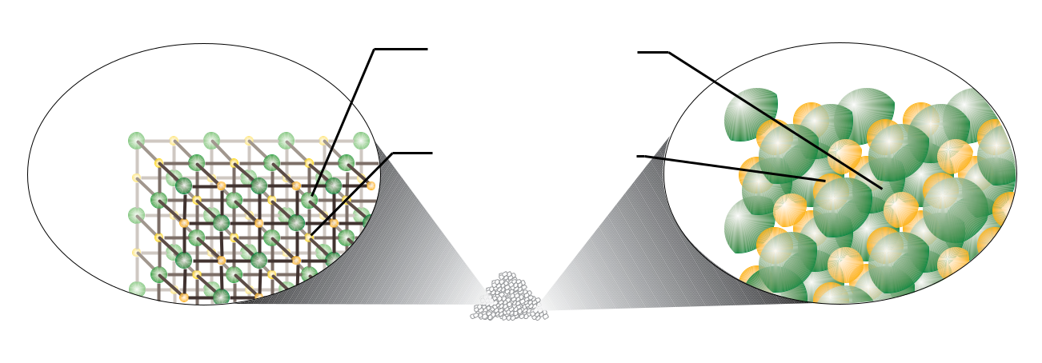

Each chloride anion

is surrounded by

six cations.

Each sodium cation

is surrounded by

six anions.

Ball-and-stick model  Space-filling model

Salt (sodium chloride)

|  |  |  |
| --- | --- | --- |
|  | **Figure 3.18** |  |
| Objective 32 |  |
| Sodium Chloride Structure |  |
|  |  |

**Polyatomic Ions**

When an electric current is run through a purified saltwater solution (brine), hydrogen gas, chlorine gas, and an ionic compound called sodium hydroxide, NaOH, form. The sodium hydroxide, commonly called caustic soda or lye, is a very important compound that is used in paper production, vegetable oil refining, and to make many different compounds, such as soap and rayon. Like sodium chloride, NaCl, sodium hydroxide, NaOH, contains a cation and an anion, but unlike the monatomic Cl- anion in NaCl, the hydroxide ion, OH-, in NaOH is a **polyatomic ion**, a charged *collection* of atoms held together by covalent bonds. To show the charge, Lewis structures of polyatomic ions are often enclosed in brackets, with the charge indicated at the top right. The Lewis structure for hydroxide is



O H



hydroxide

Note in the Lewis structure above that the oxygen atom does not have its most common bonding pattern, two bonds and two lone pairs. The gain or loss of electrons in the formation of polyatomic ions leads to one or more atoms in the ions having a different number of bonds and lone pairs than is predicted on Table 3.1.

The Lewis structure of the ammonium ion, NH4+, the only common polyatomic cation, is

|  |  |  |  |  |  |  |  |  |  |
| --- | --- | --- | --- | --- | --- | --- | --- | --- | --- |
|  |  |  | H | |  | |  | + |  |
|  |  |  |  |  |
|  |  |  |  |  |  |  |  |  |  |
| H | |  | N | |  | H | |  |  |
|  |  |  |
|  |  |  |  |  |  |  |  |  |  |
|  |  |  | H | |  |  |  |  |  |

|  |  |  |
| --- | --- | --- |
| ammonium ion |  |  |
| The ammonium ion can take the place of a monatomic cation in an ionic crystal |  |  |
| structure. For example, the crystal structure of ammonium chloride, NH4Cl, which |  |  |
| Objective 33 |  |
|  |  |
| is found in fertilizers, is very similar to the crystal structure of cesium chloride, CsCl, |  |  |
| which is used in brewing, mineral waters, and to make fluorescent screens. In each |  |  |
| structure, the chloride ions form a cubic arrangement with chloride ions at the corners |  |  |

102 Chapter 3  Chemical Compounds

of each cube. In cesium chloride, the cesium ions sit in the center of each cube, surrounded by eight chloride ions. Ammonium chloride has the same general structure as cesium chloride, with ammonium ions playing the same role in the NH4Cl structure as cesium ions play in CsCl. The key idea is that because of its overall positive charge, the polyatomic ammonium ion acts like the monatomic cesium ion, Cs+ (Figure 3.19).

**Figure 3.19**

Cesium Chloride Crystal Structure

Objective 33

Cesium

chloride

Ammonium

chloride

Objective 34

Each Cs+ cation

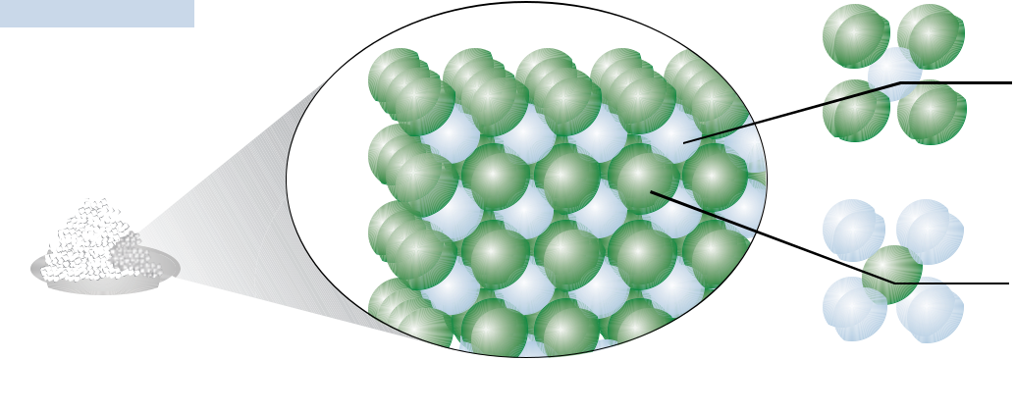

is surrounded by

eight Cl − anions.

Each Cl − anion

is surrounded by

eight Cs+ cations.

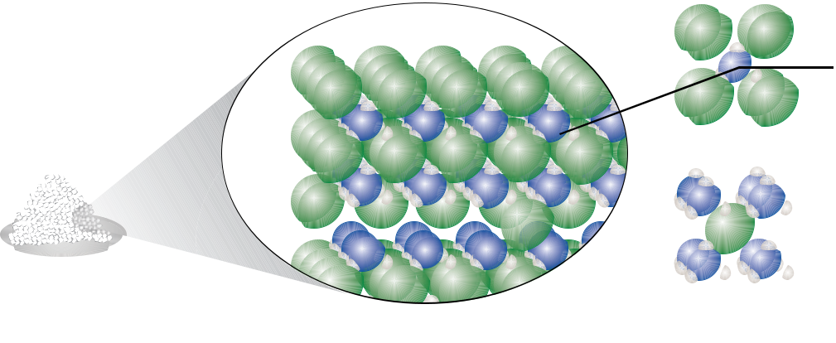

Each NH4+ cation

is surrounded by

eight Cl − anions.

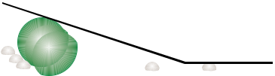 Each Cl − anion

is surrounded by

eight NH4+ cations.

There are many polyatomic anions that can take the place of monatomic anions. For example, zinc hydroxide, used as an absorbent in surgical dressings, has a similar structure to zinc chloride, which is used in embalming and taxidermist’s fluids. The hydroxide ion, OH-, plays the same role in the structure of Zn(OH)2 as the chloride ion, Cl-, plays in ZnCl2. (Note that to show that there are two hydroxide ions for each zinc ion, the OH is in parentheses, with a subscript of 2.)

It is very useful to be able to convert between the names and formulas of the common polyatomic ions listed in Table 3.6. Check with your instructor to find out which of these you will be expected to know and whether there are others you should know as well.

|  |  |  |  |  |  |  |  |  |  |
| --- | --- | --- | --- | --- | --- | --- | --- | --- | --- |
|  |  |  |  |  | 3.5 Ionic Compounds | | | 103 |  |
| **Table 3.6** |  |  |  |  |  |  |  |  |  |
|  |  |  |  |  |  | Objective 34 |  |  |
| Common Polyatomic Ions | |  |  |  |  |  |  |  |
|  |  |  |  |  |  |  |  |
|  |  |  |  |  |  |  |  |  |  |
| Ion | Name | Ion | Name | Ion | Name |  |  |  |  |
|  |  |  |  |  |  |  |  |  |  |
| NH4+ | ammonium | PO43- | phosphate | SO42- | sulfate |  |  |  |  |
| OH- | hydroxide | NO3- | nitrate | C2H3O2- | acetate |  |  |  |  |
| CO32- | carbonate |  |  |  |  |  |  |  |  |

|  |  |  |
| --- | --- | --- |
| Some polyatomic anions are formed by the attachment of one or more hydrogen |  |  |
| Objective 35 |  |
| atoms. In fact, it is common for hydrogen atoms to be transferred from one ion or |  |  |
| molecule to another ion or molecule. When this happens, the hydrogen atom is usually |  |  |
| transferred without its electron, as H+. If an anion has a charge of −2 or −3, it can gain |  |  |
| one or two H+ ions and still retain a negative charge. For example, carbonate, CO32−, |  |  |
| can gain an H+ ion to form HCO3-, which is found in baking soda. The sulfide ion, |  |  |
| S2-, can gain one H+ ion to form HS-. Phosphate, PO43-, can gain one H+ ion and form |  |  |
| HPO42-, or it can gain two H+ ions to form H2PO4-. Both HPO42- and H2PO4- are |  |  |
| found in flame retardants. These polyatomic ions are named with the word *hydrogen* in |  |  |
| front of the name of the anion if there is one H+ ion attached and *dihydrogen* in front |  |  |
| of the name of the anion if two H+ ions are attached. |  |  |
| HCO3- is hydrogen carbonate ion. |  |  |
| HS- is hydrogen sulfide ion. |  |  |
| HPO42- is hydrogen phosphate ion. |  |  |
| H2PO4- is dihydrogen phosphate ion. |  |  |
| Some polyatomic ions also have nonsystematic names that are often used. For |  |  |
| example, HCO3- is often called bicarbonate instead of hydrogen carbonate. You |  |  |
| Objective 36 |  |
|  |  |
| should avoid using this less accepted name, but because many people still use it, you |  |  |
| should know it. |  |  |

[**You can find a more comprehensive description of polyatomic ions, including a**](http://preparatorychemistry.com/Bishop_Oxyanions.htm)[**longer list of their names and formulas at the textbook’s Web site.**](http://preparatorychemistry.com/Bishop_Oxyanions.htm)

104 Chapter 3  Chemical Compounds

**Converting Formulas to Names**

As we noted earlier, chemists have established different sets of rules for writing the

Objective 37 names and formulas of different types of chemical compounds, so the first step in writing a name from a chemical formula is to decide what type of compound the formula represents. A chemical formula for an ionic compound will have one of the following forms.

**Metal‑nonmetal:** Ionic compounds whose formula contains one symbol fora metal and one symbol for a nonmetal are called **binary ionic compounds**. Their general formula is MaAb, with *M* representing the symbol of a metallic element, *A* representing the symbol for a nonmetallic element, and lowercase *a* and *b* representing subscripts in the formula (unless one or more of the subscripts are assumed to be 1). For example, NaF (used to fluoridate municipal waters), MgCl2 (used in floor sweeping compounds), and Al2O3 (in ceramic glazes) represent binary ionic compounds.



|  |  |  |  |  |
| --- | --- | --- | --- | --- |
| Metallic element | |  | Nonmetallic element |  |
| Binary ionic compound |  |  | MaAb |  |
|  |  |  |
|  |  | Subscripts (may be absent) | |  |



**Metal‑polyatomic ion:** Polyatomic ions can take the place of monatomicanions, so formulas that contain a symbol for a metallic element and the formula for a polyatomic ion represent ionic compounds. For example, NaNO3 (in solid rocket propellants) and Al2(SO4)3 (a foaming agent in fire foams) represent ionic compounds.

**Ammonium‑nonmetal or ammonium‑polyatomic ion:** Ammonium ions,NH4+, can take the place of metallic cations in an ionic compound, so chemical formulas that contain the formula for ammonium with either a symbol for a nonmetallic element or a formula for a polyatomic ion represent ionic compounds. For example, NH4Cl (in dry cell batteries), (NH4)2S (used to color brass), and (NH4)2SO4 (in fertilizers) represent ionic compounds.



Objective 37 The names of ionic compounds consist of the name for the cation followed by the name for the anion. Tables 3.7 and 3.8 summarize the ways cations and anions are named.

|  |  |  |  |  |  |  |  |  |  |  |
| --- | --- | --- | --- | --- | --- | --- | --- | --- | --- | --- |
|  |  |  |  |  | 3.5 Ionic Compounds | | | | 105 |  |
| **Table 3.7** |  |  |  |  |  |  |  |  |  |  |
|  |  |  |  |  |  |  | Objective 37 |  |  |
| Summary of the Ways Cations Are Named | |  |  |  |  |  |  |  |  |
|  |  |  |  |  |  |  |  |  |
|  |  |  |  |  |  |  |  |  |  |  |
| Type of cation |  | General name | |  | Example | | |  |  |  |
|  |  |  |  |  |  |  |  |  |  |  |
| metal with one possible charge | | name of metal | |  | Mg2+ is magnesium. | | |  |  |  |
| (groups 1, 2, 3–Al, Zn, and Cd) | |  |  |  |  |  |  |  |  |  |
|  |  |  |  |  |  |  |  |  |  |  |
| metal with more than one possible charge | | name of metal | |  | Cu2+ is copper(II). | | |  |  |  |
| (the rest of the metallic elements) | | (Roman numeral) | | |  |  |  |  |  |  |
|  |  |  |  |  |  |  |  |  |  |  |
| polyatomic cations |  | name of | |  | NH4+ is ammonium. | | |  |  |  |
| (for us, only ammonium) | | polyatomic cation | | |  |  |  |  |  |  |
|  |  |  |  |  |  |  |  |  |  |  |
| **Table 3.8** |  |  |  |  |  |  |  |  |  |  |
|  |  |  |  |  |  |  | Objective 37 |  |  |
| Summary of the Ways Anions Are Named | |  |  |  |  |  |  |  |  |
|  |  |  |  |  |  |  |  |  |
|  |  |  |  |  | |  | | |  |  |
| Type of anion | General name |  |  | Example | |  | | |  |  |
|  |  | |  |  | |  | | |  |  |
| monatomic anions | (root of nonmetal)ide | |  | O2- is oxide. | |  | | |  |  |
| polyatomic anions | name of polyatomic anion | |  | NO3- is nitrate. | |  |  |  |  |  |

As an example of the thought‑process for naming ionic compounds, let’s write the name for MnO (used as a food additive and dietary supplement). Our first step is to identify the type of compound it represents. Because it is composed of a metallic element and a nonmetallic element, we recognize it as ionic. Thus we must write the name of the cation followed by the name of the anion. Manganese is not on our list of metallic elements with only one possible charge, so the cation’s name is the name of the element followed by a Roman numeral that represents the charge. Therefore, our next step is to determine the charge on each manganese cation in MnO.

When the cation in an ionic formula is created from a metallic element whose atoms can have more than one charge, you can discover the cation’s charge by identifying the charge on the anion and then figuring out what charge the cation must have to yield a formula that is uncharged overall. To discover the charge on the manganese ions in MnO, you first determine the charge on the anions. A glance at the periodic table shows oxygen to be in group 16, or 6A, whose nonmetallic members always form −2 ions. With *x* representing the charge on the manganese ion, the charge on the manganese cation can be figured out as follows:

total cation charge + total anion charge = 0

x + (−2) = 0

x = +2

Each manganese cation must therefore be +2 to balance the −2 of the oxide to yield an uncharged ionic formula. The systematic name for Mn2+ is *manganese(II)*. Monatomic anions are named with the root of the nonmetal followed by –ide, so O2- is *oxide*. MnO is named manganese(II) oxide. Example 3.8 provides other examples.

106 Chapter 3 

Objective 37

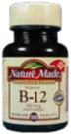

CoCl2 is used to make vitamin B-12.

Chemical Compounds



Example 3.8 - Naming Ionic Compounds

Write the names that correspond to the following formulas: (a) MgO (used to make aircraft windshields), (b) CoCl2 (used to manufacture vitamin B-12), (c) NH4NO3 (used to make explosives), and (d) Fe2O3 (in paint pigments).

*Solution*

a. The compound MgO includes the cation Mg2+ and the anion O2-. Magnesium cations are always +2, so the name of the cation is the same as the name of the metallic element. The anion O2- is monatomic, so it is named by combining the root of the name of the nonmetal with -ide. Therefore, MgO is **magnesium**

**oxide**.

b. Cobalt is not on our list of metallic elements that form ions with only one charge, so we assume it can form ions with more than one possible charge. Therefore, we need to show the charge on the cobalt ion with a Roman numeral in parentheses after the name cobalt. The cobalt ion must be +2 to balance the -2 from the two -1 chloride ions.

Total cation charge + total anion charge = 0

x + 2(-1) = 0

x = +2

The anion Cl- is monatomic, so its name includes the root of the name of the nonmetal and -ide. Therefore, CoCl2 is **cobalt(II) chloride**.

c. The compound NH4NO3 includes the cation NH4+ and the anion NO3-. Both of these ions are polyatomic ions with names you should memorize. The name of NH4NO3 is **ammonium nitrate**.

1. Iron is not on our list of metallic elements that form ions with only one charge, so we need to show the charge on the iron ion with a Roman numeral. Because oxygen atoms have two fewer electrons than the nearest noble gas, neon, they form -2 ions. In the following equation, *x* represents the charge on each iron ion. Because there are two iron ions, 2*x* represents the total cation charge. Likewise, because there are three oxygen ions, the total anion charge is three times the charge on each oxygen ion.

total cation charge + total anion charge = 0

2x + 3(-2) = 0

x = +3

The iron ions must be +3 in order for them to balance the -6 from three -2 oxide ions, so the cation name is iron(III). Because O2- is a monatomic anion, its name includes the root of the name of the nonmetal and ‑ide. Therefore, Fe2O3 is **iron(III) oxide**.



Exercise 3.8 - Naming Ionic Compounds

Objective 37 Write the names that correspond to the following formulas: (a) LiCl (used in soft drinks to help reduce the escape of bubbles), (b) Cr2(SO4)3 (used in chrome plating), and (c) NH4HCO3 (used as a leavening agent for cookies, crackers, and cream puffs).

|  |  |
| --- | --- |
| 3.5 Ionic Compounds | 107 |

**Converting Names of Ionic Compounds to Formulas**

Before you can write a chemical formula from the name of a compound, you need to recognize what type of compound the name represents. For binary ionic compounds, the first part of the name is the name of a metallic cation. This may include a Roman numeral in parentheses. The anion name starts with the root of the name of a nonmetal and ends with *‑ide*.

(name of metal)(maybe Roman numeral) (root of nonmetal)ide

For example, aluminum fluoride (used in the production of aluminum) and tin(II) chloride (used in galvanizing tin) are binary ionic compounds.

You can identify other names as representing ionic compounds by recognizing that they contain the names of common polyatomic ions. For example, ammonium chloride and iron(III) hydroxide are both ionic compounds. Many of the polyatomic ions that you will be expected to recognize end in *‑ate*, so this ending tells you that the name represents an ionic compound. Copper(II) sulfate is an ionic compound.

Follow these steps to write formulas for ionic compounds.

**Step 1** Write the formula, including the charge, for the cation. (See Figure3.17 to review the charges on monatomic cations.)

**Step 2** Write the formula, including the charge, for the anion. (See Figure3.17 to review the charges on monatomic anions. See Table 3.6 to review polyatomic ion formulas.)

**Step 3** Write subscripts for each formula so as to yield an unchargedcompound. Table 3.9 shows examples.

Use the lowest whole number ratio for the subscripts.

If the subscript for a polyatomic ion is higher than one, place the formula for the polyatomic ion in parentheses and put the subscript outside the parentheses.

Objective 37



Objective 37

|  |  |  |  |  |  |  |
| --- | --- | --- | --- | --- | --- | --- |
| **Table 3.9** |  |  |  |  |  |  |
|  |  |  |  | Objective 37 |  |
| Possible Cation-Anion Ratios (X represents the cation, and Y represents the anion.) | | | |  |  |
|  |  |  |
|  |  |  |  |  |  |  |
| Ionic charges | General formula | Example ions | Example formula |  |  |  |
| X+ and Y- | XY | Na+ and Cl- | NaCl |  |  |  |
| X+ and Y2- | X2Y | NH4+ and SO42- | (NH4)2SO4 |  |  |  |
| X+ and Y3- | X3Y | Li+ and PO43- | Li3PO4 |  |  |  |
| X2+ and Y- | XY2 | Mg2+ and NO3- | Mg(NO3)2 |  |  |  |
| X2+ and Y2- | XY | Ca2+ and CO32- | CaCO3 |  |  |  |
| X2+ and Y3- | X3Y2 | Ba2+ and N3- | Ba3N2 |  |  |  |
| X3+ and Y- | XY3 | Al3+ and F- | AlF3 |  |  |  |
| X3+ and Y2- | X2Y3 | Sc3+ and S2- | Sc2S3 |  |  |  |
| X3+ and Y3- | XY | Fe3+ and PO43- | FePO4 |  |  |  |

108 Chapter 3 

Objective 37

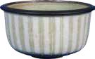

Cr2O3 is a pigment used for coloring pottery glazes.

[**There is a tutorial**](https://preparatorychemistry.com/ionic_nomenclature_Canvas.html)[**on the textbook’s**](https://preparatorychemistry.com/ionic_nomenclature_Canvas.html)[**Web site that**](https://preparatorychemistry.com/ionic_nomenclature_Canvas.html)[**provides practice**](https://preparatorychemistry.com/ionic_nomenclature_Canvas.html)[**converting**](https://preparatorychemistry.com/ionic_nomenclature_Canvas.html)[**between names**](https://preparatorychemistry.com/ionic_nomenclature_Canvas.html)[**and formulas of**](https://preparatorychemistry.com/ionic_nomenclature_Canvas.html)[**ionic compounds.**](https://preparatorychemistry.com/ionic_nomenclature_Canvas.html)

Chemical Compounds



Example 3.9 - Formulas of Ionic Compounds

Write the chemical formulas that correspond to the following names: (a) aluminum chloride (used in cosmetics), (b) chromium(III) oxide (a pigment for coloring pottery glazes), (c) calcium nitrate (provides a red‑orange color in fireworks), and (d) ammonium sulfide (used to make synthetic flavors).

*Solution*

1. Aluminum chloride has the form *(name of metal) (root of nonmetal)ide*, so we recognize it as a binary ionic compound. Because aluminum atoms have three more electrons than the nearest noble gas, neon, they lose three electrons and form +3 ions. Because chlorine atoms have one fewer electron than the nearest noble gas, argon, they gain one electron to form −1 ions. The formulas for the individual ions are Al3+ and Cl-. It would take three chlorides to neutralize the +3 aluminum ion, so the formula for the compound is AlCl3.
2. Chromium(III) oxide has the form *(name of metal)(Roman numeral) (root of* *nonmetal)ide*, so it represents a binary ionic compound. The *(III)* tells you thatthe chromium ions have a +3 charge. Because oxygen atoms have two fewer electrons than the nearest noble gas, neon, they gain two electrons to form -2 ions. The formulas for the ions are Cr3+ and O2-. When the ionic charges are +3 and -2 (or +2 and -3), a simple procedure will help you to determine the subscripts in the formula. Disregarding the signs of the charges, use the superscript on the anion as the subscript on the cation, and use the superscript on the cation as the subscript on the anion.

Cr3+ O2−

Chromium(III) oxide is Cr2O3.

1. Calcium nitrate has the form *(name of metal) (name of a polyatomic ion)*, so it represents an ionic compound. (The *-ate* at the end of nitrate tells us that it is a polyatomic ion.) Calcium is in group 2 on the periodic table. Because all metals in group 2 have two more electrons than the nearest noble gas, they all lose two electrons and form +2 ions. Nitrate is NO3-, so two nitrate ions are needed to neutralize the charge on the Ca2+. Calcium nitrate is Ca(NO3)2. Notice that in order to show that there are two nitrate ions, the formula for nitrate is placed in parentheses.
2. Ammonium sulfide has the form *ammonium (root of a nonmetal)ide*, so it represents an ionic compound. You should memorize the formula for ammonium, NH4+. Sulfur has two fewer electrons than the noble gas, argon, so it gains two electrons and forms a -2 anion. Two ammonium ions would be necessary to neutralize the -2 sulfide. Ammonium sulfide is (NH4)2S.



Exercise 3.9 - Formulas of Ionic Compounds

Objective 37 Write the formulas that correspond to the following names: (a) aluminum oxide (used to waterproof fabrics), (b) cobalt(III) fluoride (used to add fluorine atoms to compounds),

1. iron(II) sulfate (in enriched flour), (d) ammonium hydrogen phosphate (coats vegetation to retard forest fires), and (e) potassium bicarbonate (in fire extinguishers).

|  |  |
| --- | --- |
| Chapter Glossary | 109 |



**Compound** A substance that contains two or more elements, the atoms of these elements always combining in the same whole-number ratio.

**Chemical formula** A concise written description of the components of a chemicalcompound. It identifies the elements in the compound by their symbols and indicates the relative number of atoms of each element with subscripts.

**Pure substance** A sample of matter that has constant composition. There are two typesof pure substances, elements and compounds.

**Mixture** A sample of matter that contains two or more pure substances and has variablecomposition.

**Chemical bond** An attraction between atoms or ions in chemical compounds. Covalentbonds and ionic bonds are examples.

**Polar covalent bond** A covalent bond in which electrons are shared unequally, leadingto a partial negative charge on the atom that attracts the electrons more and to a partial positive charge on the other atom.

**Nonpolar covalent bond** A covalent bond in which the difference in electron-attractingability of two atoms in a bond is negligible (or zero), so the atoms in the bond have no significant charges.

**Ionic bond** The attraction between a cation and an anion.

**Molecular compound** A compound composed of molecules. In such compounds, allof the bonds between atoms are covalent bonds.

**Ionic Compound** A compound that consists of ions held together by ionic bonds. **Valence electrons** The electrons that are most important in the formation of chemical

bonds. The number of valence electrons for the atoms of an element is equal to the element’s A-group number on the periodic table. (A more comprehensive definition of valence electrons appears in Chapter 12.)

**Electron-dot symbol** A representation of an atom that consists of its elemental symbolsurrounded by dots representing its valence electrons.

**Lewis structure** A representation of a molecule that consists of the elemental symbolfor each atom in the molecule, lines to show covalent bonds, and pairs of dots to indicate lone pairs.

**Lone pair** Two electrons that are not involved in the covalent bonds between atomsbut are important for explaining the arrangement of atoms in molecules. They are represented by pairs of dots in Lewis structures.

**Hydrocarbons** Compounds that contain only carbon and hydrogen.

**Organic chemistry** The branch of chemistry that involves the study of carbon-basedcompounds.

**Double bond** A link between atoms that results from the sharing of four electrons. Itcan be viewed as two 2‑electron covalent bonds.

**Triple bond** A link between atoms that results from the sharing of six electrons. It canbe viewed as three 2‑electron covalent bonds.

**Alcohols** Compounds that contain a hydrocarbon group with one or more -OH groups attached.

**Tetrahedral** The molecular shape that keeps the negative charge of four electrongroups as far apart as possible. This shape has angles of 109.5° between the atoms.

**Bond angle** The angle formed by straight lines (representing bonds) connecting thenuclei of three adjacent atoms.

Chapter

Glossary

110 Chapter 3  Chemical Compounds

**Binary covalent compound** A compound that consists of two nonmetallic elements. **Monatomic anions** Negatively charged particles, such as Cl-, O2-, and N3-, that

contain single atoms with a negative charge.

**Monatomic cations** Positively charged particles, such as Na+, Ca2+, and Al3+, that contain single atoms with a positive charge.

**Polyatomic ion** A charged collection of atoms held together by covalent bonds. **Binary ionic compound** An ionic compound whose formula contains one symbol for

a metal and one symbol for a nonmetal.

[**You can test yourself on the glossary terms at the textbook’s Web site.**](https://preparatorychemistry.com/Glossary_3_CF_Canvas.html)



Chapter Objectives

**The goal of this chapter is to teach you to do the following.** 1. Define all of the terms in the Chapter Glossary. **Section 3.1 Classification of Matter**

1. Convert between a description of the number of atoms of each element found in a compound and its chemical formula.
2. Given a description of a form of matter, classify it as a pure substance or mixture.
3. Given a description of a pure substance, classify it as an element or compound.

**Section 3.2 Chemical Compounds and Chemical Bonds**

1. Describe the polar covalent bond between two nonmetallic atoms, one of which attracts electrons more than the other one does. Your description should include a rough sketch of the electron-cloud that represents the electrons involved in the bond.
2. Describe the process that leads to the formation of ionic bonds between metallic and nonmetallic atoms.
3. Describe the difference between a nonpolar covalent bond, a polar covalent bond, and an ionic bond. Your description should include rough sketches of the electron-clouds that represent the electrons involved in the formation of each bond.
4. Given the names or formulas for two elements, identify the bond that would form between them as covalent or ionic.
5. Given a formula for a compound, classify it as either a molecular compound or an ionic compound.

**Section 3.3 Molecular Compounds**

1. Determine the number of valence electrons for the atoms of each of the nonmetallic elements.
2. Draw electron-dot symbols for the nonmetallic elements and use them to explain why these elements form the bonding patterns listed in Table 3.1.
3. Give a general description of the information provided in a Lewis structure.

|  |  |
| --- | --- |
| Chapter Objectives | 111 |

1. Identify the most common number of covalent bonds and lone pairs for the atoms of each of the following elements: hydrogen, the halogens (group 17), oxygen, sulfur, selenium, nitrogen, phosphorus, and carbon.
2. Convert between the following systematic names and their chemical formulas: methanol, ethanol, and 2‑propanol.
3. Given one of the following names for alcohols, write its chemical formula: methyl alcohol, ethyl alcohol, and isopropyl alcohol.
4. Given a chemical formula, draw a Lewis structure for it that has the most common number of covalent bonds and lone pairs for each atom.
5. Describe the tetrahedral molecular shape.
6. Explain why the atoms in the CH4 molecule have a tetrahedral molecular shape.

19. Describe the information given by a space‑filling model, a ball‑and‑stick model, and a geometric sketch.

1. Draw geometric sketches, including bond angles, for CH4, NH3, and H2O.
2. Describe attractions between H2O molecules.
3. Describe the structure of liquid water.

**Section 3.4 Naming Binary Covalent Compounds**

1. Convert between the names and chemical formulas for water, ammonia, methane, ethane, and propane.
2. Given a formula or name for a compound, identify whether it represents a binary covalent compound.
3. Write or identify prefixes for the numbers 1-10. (For example, mono‑ represents one, di‑ represents two, etc.)
4. Write or identify the roots of the names of the nonmetallic elements. (For example, the root for oxygen is ox‑).
5. Convert among the complete name, the common name, and the chemical formula for HF, HCl, HBr, HI, and H2S.
6. Convert between the systematic names and chemical formulas for binary covalent compounds.

**Section 3.5 Ionic Compounds**

1. Explain why metals usually combine with nonmetals to form ionic bonds.
2. Write the ionic charges acquired by the following elements:
   1. group 17 – halogens
   2. oxygen, sulfur, and selenium
   3. nitrogen and phosphorus
   4. hydrogen
   5. group 1 - alkali metals
   6. group 2 - alkaline earth metals
   7. group 3 elements
   8. aluminum
   9. iron, silver, copper, and zinc
3. Convert between the names and chemical formulas for the monatomic ions.

112 Chapter 3  Chemical Compounds

1. Describe the crystal structure of sodium chloride, NaCl.
2. Describe the similarities and differences between the ionic structure of cesium chloride and ammonium chloride.
3. Convert between the names and chemical formulas for common polyatomic ions such as hydroxide, ammonium, acetate, sulfate, nitrate, phosphate, and carbonate. *Be sure to check with your instructor to determine which polyatomic ions* *you will be expected to know for your exams.*
4. Convert between the names and chemical formulas for the polyatomic anions that are derived from the additions of H+ ions to anions with −2 or −3 charges. For example, H2PO2- is dihydrogen phosphate.
5. Write the chemical formula corresponding to the common name bicarbonate.
6. Convert between the names and chemical formulas for ionic compounds.



Review Questions

For problems 1-6, write in each blank the word or words that best complete each sentence.

1. An atom or group of atoms that has lost or gained one or more electrons to create a charged particle is called a(n) _____________________.
2. An atom or collection of atoms with an overall positive charge is a(n)

__________________.

1. An atom or collection of atoms with an overall negative charge is a(n)

__________________.

1. A(n) ______________________ bond is a link between atoms that results from the sharing of two electrons.
2. A(n) ______________________ is an uncharged collection of atoms held together with covalent bonds.
3. A molecule like H2, which is composed of two atoms, is called

__________________.

1. Describe the particle nature of solids, liquids, and gases. Your description should include the motion of the particles and the attractions between the particles.
2. Describe the nuclear model of the atom.
3. Describe the hydrogen molecule, H2. Your description should include the nature of the link between the hydrogen atoms and a sketch that shows the two electrons in the molecule.

|  |  |
| --- | --- |
| Key Ideas | 113 |

1. Complete the following table.

|  |  |  |  |
| --- | --- | --- | --- |
| Element Name | Element symbol | Group number of | Metal, nonmetal, |
|  |  | periodic table | or metalloid? |
|  |  |  |  |
|  | Li |  |  |
| carbon |  |  |  |
|  | Cl |  |  |
| oxygen |  |  |  |
|  | Cu |  |  |
| calcium |  |  |  |
|  | Sc |  |  |

1. Write the name of the group to which each of the following belongs.

a. chlorine

c. sodium

b. xenon

d. magnesium



|  |  |  |
| --- | --- | --- |
| Complete the following statements by writing one of these words or phrases in each | | Key Ideas |
| blank. |  |  |
| δ+ | lose |  |
| δ− | molecular |  |
| anion-anion and cation-cation repulsions | molecules |  |
| anions | monatomic cations |  |
| arranged in space | negative |  |
| binary | negligible (or zero) |  |
| cation-anion attraction | noble gas |  |
| cations | nonmetallic |  |
| compounds | octet |  |
| constant composition | partial negative |  |
| constantly breaking | partial positive |  |
| covalent | positive |  |
| double | repel |  |
| eight valence | same average distance apart |  |
| electron-charge clouds | smaller |  |
| forming new attractions | solids |  |
| four | specific type of compound |  |
| four electrons | strongly |  |
| gain | subscripts |  |
| gases | symbols |  |
| H+ | usually ionic |  |
| larger | variable |  |
| liquids | whole-number ratio |  |

1. A compound is a substance that contains two or more elements, the atoms of those elements always combining in the same _____________.
2. There are relatively few chemical elements, but there are millions of chemical

_____________.

114 Chapter 3  Chemical Compounds

1. A chemical formula is a concise written description of the components of a chemical compound. It identifies the elements in the compound by their

_____________ and indicates the relative number of atoms of each element with

_____________.

1. When a substance has a(n) _____________, it must by definition be either an element or a compound, and it is considered a pure substance.
2. Mixtures are samples of matter that contain two or more pure substances and have _____________ composition.
3. When the difference in electron‑attracting ability between atoms in a chemical bond is _____________, the atoms in the bond will have no significant partial charges. We call this type of bond a nonpolar covalent bond.
4. Because particles with opposite charges attract each other, there is an attraction between _____________ and _____________. This attraction is called an ionic bond.
5. Compounds that have ionic bonds, such as the sodium chloride in table salt, are _____________ at room temperature and pressure, but compounds with all covalent bonds, such as hydrogen chloride and water, can be _____________

and _____________ as well as solids.

1. The atom in a chemical bond that attracts electrons more strongly acquires a(n)

_____________ charge, and the other atom acquires a(n) _____________

charge. If the electron transfer is significant but not enough to form ions, the atoms acquire _____________ and _____________ charges. The bond in this situation is called a polar covalent bond.

1. When a nonmetallic atom bonds to another nonmetallic atom, the bond is

_____________.

1. When a metallic atom bonds to a nonmetallic atom, the bond is

_____________.

1. _____________ compounds are composed of _____________, which are collections of atoms held together by all covalent bonds.
2. The noble gases (group 8A) have a(n) _____________ of electrons (except for helium, which has only two electrons total), and they are so stable that they rarely form chemical bonds with other atoms.
3. When atoms other than the noble‑gas atoms form bonds, they often have

_____________ electrons around them in total.

1. The sum of the numbers of covalent bonds and lone pairs for the most common bonding patterns of the atoms of nitrogen, phosphorus, oxygen, sulfur, selenium, and the halogens is ____________.
2. Atoms can form double bonds, in which _____________ are shared between atoms. Double bonds are represented by _____________ lines in a Lewis structure.
3. Lewis structures are useful for showing how the atoms in a molecule are connected by covalent bonds, but they do not always give a clear description of how the atoms are _____________.

|  |  |
| --- | --- |
| Chapter Problems | 115 |

|  |  |  |
| --- | --- | --- |
| 29. | The actual shape of a | molecule can be predicted by recognizing that the |
|  | negatively charged electrons that form covalent bonds and lone pairs | |
|  | _____________ each other. Therefore, the most stable arrangement of the | |
|  | electron groups is the molecular shape that keeps the groups as far away from | |
|  | each other as possible. |  |
| **30.** | A space‑filling model | provides the most accurate representation of the |

_____________ for the atoms in CH4.

1. Because oxygen atoms attract electrons much more _____________ than do hydrogen atoms, the O–H covalent bond is very polar, leading to a relatively large partial negative charge on the oxygen atom (represented by a(n)

_____________) and a relatively large partial positive charge on the hydrogen atom (represented by a(n) _____________).

1. As in other liquids, the attractions between water molecules are strong enough to keep them the _____________ but weak enough to allow each molecule to be

_____________ the attractions that momentarily connect it to some molecules and _____________ to other molecules.

1. To write the name that corresponds to a formula for a compound, you need to develop the ability to recognize the formula as representing a(n) ____________.
2. You can recognize binary covalent compounds from their formulas, which contain symbols for only two _____________ elements.
3. Metallic atoms hold some of their electrons relatively loosely, and as a result, they tend to _____________ electrons and form cations. In contrast, nonmetallic atoms attract electrons more strongly than metallic atoms, so nonmetals tend to

_____________ electrons and form anions.

1. Nonmetallic atoms form anions to get the same number of electrons as the nearest _____________.
2. The names of _____________ always start with the name of the metal, sometimes followed by a Roman numeral to indicate the charge of the ion.
3. When atoms gain electrons and form anions, they get _____________. When atoms lose electrons and form cations, they get significantly _____________.
4. The ions in ionic solids take the arrangement that provides the greatest

_____________ while minimizing the _____________.

1. It is common for hydrogen atoms to be transferred from one ion or molecule to another ion or molecule. When this happens, the hydrogen atom is usually transferred without its electron, as _____________.
2. Ionic compounds whose formula contains one symbol for a metal and one symbol for a nonmetal are called _____________ ionic compounds.

116 Chapter 3  Chemical Compounds



Chapter Problems

Objective 3

Objective 4

Objective 3

Objective 4

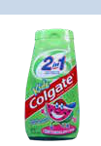

Objective 5

**Section 3.1 Classification of Matter**

1. Classify each of the following as a pure substance or a mixture. If it is a pure substance, is it an element or a compound? Explain your answer.
   1. apple juice
   2. potassium (A serving of one brand of apple juice provides 6% of the recommended daily allowance of potassium.)
   3. ascorbic acid (vitamin C), C6H8O6, in apple juice
2. Classify each of the following as a pure substance or a mixture. If it is a pure substance, is it an element or a compound? Explain your answer.
   1. fluorine (used to make fluorides, such as those used in toothpaste)
   2. toothpaste

c. calcium fluoride, CaF2, from the naturally occurring ore fluorite (It is used to make sodium monofluorophosphate, which is added to some toothpastes.)

1. Write the chemical formula for each of the following compounds. List the symbols for the elements in the order that the elements are mentioned in the description.
   1. a compound with molecules that consist of two nitrogen atoms and three oxygen atoms.
   2. a compound with molecules that consist of one sulfur atom and four fluorine atoms.
   3. a compound that contains one aluminum atom for every three chlorine atoms.
   4. a compound that contains two lithium atoms and one carbon atom for every three oxygen atoms.
2. Write the chemical formula for each of the following compounds. List the symbols for the elements in the order that the elements are mentioned in the description.
   1. a compound with molecules that consist of two phosphorus atoms and five oxygen atoms.
   2. a compound with molecules that consist of two hydrogen atoms and one sulfur atom.
   3. a compound that contains three calcium atoms for every two nitrogen atoms.
   4. a compound with molecules that consist of 12 carbon atoms, 22 hydrogen atoms, and 11 oxygen atoms.

**Section 3.2 Chemical Compounds and Chemical Bonds**

1. Hydrogen bromide, HBr, is used to make pharmaceuticals that require bromine in their structure. Each hydrogen bromide molecule has one hydrogen atom bonded to one bromine atom by a polar covalent bond. The bromine atom attracts electrons more than does the hydrogen atom. Draw a rough sketch of the electron-cloud that represents the electrons involved in the bond.

|  |  |
| --- | --- |
| Chapter Problems | 117 |

1. Iodine monochloride, ICl, is a compound used to make carbon‑based (organic) compounds that contain iodine and chlorine. It consists of diatomic molecules with one iodine atom bonded to one chlorine atom by a polar covalent bond.

The chlorine atom attracts electrons more than does the iodine atom. Draw a rough sketch of the electron-cloud that represents the electrons involved in the bond.

1. Atoms of potassium and fluorine form ions and ionic bonds in a very similar way to atoms of sodium and chlorine. Each atom of one of these elements loses one electron, and each atom of the other element gains one electron. Describe the process that leads to the formation of the ionic bond between potassium and fluorine atoms in potassium fluoride. Your answer should include mention of the charges that form on the atoms.
2. Atoms of magnesium and oxygen form ions and ionic bonds in a similar way to atoms of sodium and chlorine. The difference is that instead of having each atom gain or lose one electron, each atom of one of these elements loses two electrons, and each atom of the other element gains two electrons. Describe the process that leads to the formation of the ionic bond between magnesium and oxygen atoms in magnesium oxide. Your answer should include mention of the charges that form on the atoms.
3. Explain how a nonpolar covalent bond, a polar covalent bond, and an ionic bond differ. Your description should include rough sketches of the electron-clouds that represent the electrons involved in the formation of each bond.
4. Write a chemical formula that represents both a molecule and a compound. Write a formula that represents a compound but not a molecule.
5. Would you expect the bonds between the following atoms to be ionic or covalent

bonds?

a. N‑O b. Al-Cl

1. Would you expect the bonds between the following atoms to be ionic or covalent bonds?

a. Li‑F b. C‑N

1. Classify each of the following as either a molecular compound or an ionic compound.

a. acetone, CH3COCH3 (a common paint solvent)

b. sodium sulfide, Na2S (used in sheep dips)

1. Classify each of the following as either a molecular compound or an ionic compound.
   1. cadmium fluoride, CdF2 (a starting material for lasers)
   2. sulfur dioxide, SO2 (a food additive that inhibits browning and bacterial growth)

Objective 5

Objective 6

Objective 6

Objective 7

Objective 8

Objective 8

Objective 9



Objective 9

118 Chapter 3  Chemical Compounds

Objective 10

Objective 10

Objective 11

Objective 11

Objective 12



Objective 12

**Section 3.3 Molecular Compounds**

1. How many valence electrons does each atom of the following elements have?
   1. Cl
   2. C
2. How many valence electrons does each atom of the following elements have?
   1. N
   2. S
3. Draw electron-dot symbols for each of the following elements and use them to explain why each element has the bonding pattern listed in Table 3.1.

a. oxygen c. carbon

b. fluorine d. phosphorus

1. Draw electron-dot symbols for each of the following elements and use them to explain why each element has the bonding pattern listed in Table 3.1.
   1. iodine
   2. nitrogen
   3. sulfur
2. The following Lewis structure is for CFC-12, which is one of the

ozone‑depleting chemicals that has been used as an aerosol can propellant and as a refrigerant. Describe the information given in this Lewis structure.



F



Cl C F



Cl



1. Describe the information given in the following Lewis structure for methylamine, a compound used to make insecticides and rocket propellants.

H



H C N H



|  |  |  |  |  |  |  |
| --- | --- | --- | --- | --- | --- | --- |
|  |  |  |  |  |  |  |
|  |  | H H | | |  |  |
|  | **62.** | Write the most common number of covalent bonds and lone pairs for atoms of | | | |  |
| Objective 13 |  |
|  |  | each of the following nonmetallic elements. | | | |  |
|  |  | a. H | | | c. sulfur |  |
|  |  | b. iodine | | | d. N |  |
|  | 63. | Write the most common number of covalent bonds and lone pairs for atoms of | | | |  |
| Objective 13 |  |
|  |  | each of the following nonmetallic elements. | | | |  |
|  |  | a. C | | | c. oxygen |  |
|  |  | b. phosphorus | | | d. Br |  |
|  | **64.** | Draw a Lewis structure for each of the following formulas. | | | |  |
| Objective 16 |  |
|  |  | a. oxygen difluoride, | | | OF2 (an unstable, colorless gas) |  |

1. bromoform, CHBr3 (used as a sedative)
2. phosphorus triiodide, PI3 (used to make organic compounds)

65. Draw a Lewis structure for each of the following formulas.

a. nitrogen trifluoride, NF3 (used in high-energy fuels)

* 1. chloroethane, C2H5Cl (used to make the gasoline additive tetraethyl lead)
  2. hypobromous acid, HOBr (used as a wastewater disinfectant)

1. Draw Lewis structures for the following compounds by adding any necessary lines and dots to the skeletons given.
   1. hydrogen cyanide, HCN (used to manufacture dyes and pesticides)

H C N

b. dichloroethene, C2Cl4 (used to make perfumes)

Cl C C Cl

Cl Cl

|  |  |
| --- | --- |
| Chapter Problems | 119 |

Objective 16

Objective 16



|  |  |  |
| --- | --- | --- |
| 67. Draw Lewis structures for the following compounds by adding any necessary |  |  |
| Objective 16 |  |
| lines and dots to the skeletons given. |  |  |
| a. formaldehyde, H2CO (used in embalming fluids) |  |  |

O

H C H

b. 1-butyne, C4H6 (a specialty fuel)

H H

H C C C C H

H H

1. Write two different names for each of the following alcohols.

H



a. H C O H



H

H H



b. H C C O H



H H



|  |  |  |  |
| --- | --- | --- | --- |
| O |  | H |  |
|  |  |



H H



c. H C C C H



H H H

Objective 14

Objective 15

120 Chapter 3  Chemical Compounds

Objective 18

Objective 19

Objective 20

Objective 19

Objective 20

Objective 19

Objective 20

Objective 21

Objective 22

Objective 28

Objective 28

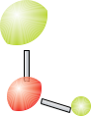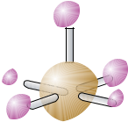

Objective 28



Objective 28

1. Explain why the atoms in the CH4 molecule are arranged with a tetrahedral molecular shape.
2. Compare and contrast the information given in the Lewis structure, the space‑filling model, the ball‑and‑stick model, and the geometric sketch of a methane molecule, CH4.
3. Compare and contrast the information given in the Lewis structure, the space‑filling model, the ball‑and‑stick model, and the geometric sketch of an ammonia molecule, NH3.
4. Compare and contrast the information given in the Lewis structure, the space‑filling model, the ball‑and‑stick model, and the geometric sketch of a water molecule, H2O.
5. What are the particles that form the basic structure of water? Describe the attraction that holds these particles together. Draw a rough sketch that shows the attraction between two water molecules.
6. Describe the structure of liquid water.

**Section 3.4 Naming Binary Covalent Compounds**

1. What is wrong with using the name *nitrogen oxide* for NO? Why can’t you be sure of the formula that corresponds to the name *phosphorus chloride*?
2. The compound represented by the ball‑and‑stick model to the left is used in the processing of nuclear fuels. Although bromine atoms most commonly form one covalent bond, they can form five bonds, as in the molecule shown here, in which the central sphere represents a bromine atom. The other atoms are fluorine atoms. Write this compound’s chemical formula and name. List the bromine atom first in the chemical formula.
3. The compound represented by the ball‑and‑stick model to the left is used to add chlorine atoms to other molecules. Write its chemical formula and name. The

|  |  |  |  |  |  |  |  |
| --- | --- | --- | --- | --- | --- | --- | --- |
|  | central ball represents an oxygen atom, and the other atoms are chlorine atoms. | | | | | |  |
|  | List the chlorine atom first in the chemical formula. | |  | |  | |  |
|  | Objective 28 | |  |
| **78.** | The compound represented by the space‑filling | model to the left is used to | | | | |  |
|  | vulcanize rubber and harden softwoods. Write its chemical formula and name. | | | | | |  |
|  | The central ball represents a sulfur atom, and the other atoms are chlorine | | | | | |  |
|  | atoms. List the sulfur atom first in the chemical formula. | | |  |  |  |  |
|  | Objective 28 | |  |
| 79. | The compound represented by the space‑filling | model to the left is used in | | | | |  |

processing nuclear fuels. The central sphere represents a chlorine atom, which in most cases would form one covalent bond but is sometimes able to form three bonds. The other atoms are fluorine atoms. Write this compound’s chemical formula and name. List the chlorine atom first in the chemical formula.

1. Write the name for each of the following chemical formulas.
   1. I2O5 ( an oxidizing agent)
   2. BrF3 (adds fluorine atoms to other compounds)
   3. IBr (used in organic synthesis)
   4. CH4 (a primary component of natural gas)
   5. HBr (used to make pharmaceuticals)

1. Write the name for each of the following chemical formulas.
   1. ClO2 (a commercial bleaching agent)
   2. C2H6 (in natural gas)
   3. HI (when dissolved in water, used to make pharmaceuticals)
   4. P3N5 (for doping semiconductors)
   5. BrCl (an industrial disinfectant)
2. Write the chemical formula for each of the following names.
   1. propane (a fuel in heating torches)
   2. chlorine monofluoride (a fluorinating agent)
   3. tetraphosphorus heptasulfide (dangerous fire risk)
   4. carbon tetrabromide (used to make organic compounds)
   5. hydrogen fluoride (an additive to liquid rocket propellants)
3. Write the chemical formula for each of the following names.
   1. ammonia (a household cleaner when dissolved in water)
   2. tetraphosphorus hexasulfide (used in organic chemical reactions)
   3. iodine monochloride (used for organic synthesis)
   4. hydrogen chloride (used to make hydrochloric acid)

**Section 3.5 Ionic Compounds**

1. Explain why metals usually combine with nonmetals to form ionic bonds.
2. How may protons and electrons do each of the following ions have?
   1. Be2+
   2. S2-
3. How may protons and electrons do each of the following ions have?
   1. N3-
   2. Ba2+
4. Write the name for each of these monatomic ions.

|  |  |  |
| --- | --- | --- |
| a. Ca2+ | e. | Ag+ |
| b. Li+ | f. | Sc3+ |
| c. Cr2+ | g. | P3- |
| d. F- | h. | Pb2+ |

88. Write the name for each of these monatomic ions.

|  |  |  |  |
| --- | --- | --- | --- |
| a. | Na+ | e. | Se2- |
| b. | Br- | f. | Zn2+ |
| c. | Al3+ | g. | Cr3+ |

* 1. Mn2+

1. Write the formula for each of these monatomic ions.

|  |  |  |  |
| --- | --- | --- | --- |
| a. | magnesium ion | e. | scandium ion |
| b. | sodium ion | f. | nitride ion |
| c. | sulfide ion | g. | manganese(III) ion |
| d. | iron(III) ion | h. | zinc ion |

|  |  |
| --- | --- |
| Chapter Problems | 121 |

Objective 28

Objective 28

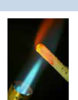

Objective 28

Objective 29

Objective 30

Objective 30

Objective 30

Objective 31

122 Chapter 3  Chemical Compounds

Objective 30

Objective 31

Objective 32

Objective 33

Objective 34

Objective 35

Objective 34

Objective 35

Objective 34

Objective 35

Objective 36

Objective 37



Objective 37

Objective 37

90. Write the formula for each of these monatomic ions.

|  |  |  |  |
| --- | --- | --- | --- |
| a. | strontium ion | f. | oxide ion |
| b. | aluminum ion | g. | chloride ion |
| c. | silver ion | h. | copper(I) ion |
| d. | nickel(II) ion | i. | mercury(II) ion |

* 1. potassium ion

1. Silver bromide, AgBr, is the compound on black and white film that causes the color change when the film is exposed to light. It has a structure similar structure to that of sodium chloride. What are the particles that form the basic structure of silver bromide? What type of attraction holds these particles together? Draw a rough sketch of the structure of solid silver bromide.
2. Describe the crystal structures of cesium chloride and ammonium chloride. How are they similar, and how are they different?
3. Write the name for each of these polyatomic ions.

a. NH4+ c. HSO4-

* 1. C2H3O2-

1. Write the name for each of these polyatomic ions.

a. OH- c. HCO3-

* 1. CO32-

1. Write the formula for each of these polyatomic ions.

a. ammonium ion c. hydrogen sulfate ion

* 1. bicarbonate ion

1. Write the name for each of these chemical formulas.
   1. Na2O (a dehydrating agent)
   2. Ni2O3 (in storage batteries)
   3. Pb(NO3)2 (in matches and explosives)
   4. Ba(OH)2 (an analytical reagent)
   5. KHCO3 (in baking powder and fire-extinguishing agents)
2. Write the name for each of these chemical formulas.
   1. CdI2 (a nematocide—that is, it kills certain parasitic worms.)
   2. Ca3P2 (in signal flares)
   3. Au(OH)3 (used in gold plating)
   4. FeCl2 (in pharmaceutical preparations)
   5. NH4HSO4 (in hair wave formulations)
3. Write the chemical formula for each of the following names.
   1. potassium sulfide (a depilatory)
   2. zinc phosphide (a rodenticide)
   3. nickel(II) chloride (used in nickel electroplating)
   4. magnesium dihydrogen phosphate (used in fireproofing wood)
   5. lithium bicarbonate (in mineral waters)

1. Write chemical formulas for each of the following names.
   1. barium chloride (used in manufacture of white leather)
   2. cobalt(III) oxide (used in coloring enamels)
   3. manganese(II) chloride (used in pharmaceutical preparations)
   4. iron(III) acetate (a medicine)
   5. chromium(III) phosphate (in paint pigments)
   6. magnesium hydrogen phosphate (a laxative)
2. The ionic compounds CuF2, NH4Cl, CdO, and HgSO4 are all used to make batteries. Write the name for each of these compounds.

101. The ionic compounds MgF2, NH4OH, Ba(NO3)2, Na2HPO4, and Cu2O are all used to make ceramics. Write the name for each of these compounds.

1. The ionic compounds copper(II) chloride, lithium nitrate, and cadmium sulfide are all used to make fireworks. Write the chemical formulas for these compounds.
2. The ionic compounds barium bromide, silver phosphate, and ammonium iodide are all used in photography. Write the chemical formulas for these compounds.

**Discussion Topic**

1. It has been suggested that there is really only one type of chemical bond— that ionic and covalent bonds are not really fundamentally different. What arguments can be made for and against this position?

|  |  |
| --- | --- |
| Chapter Problems | 123 |

Objective 37

Objective 37

Objective 37

Objective 37

Objective 37